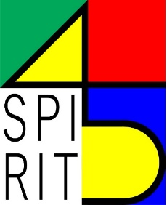

SPIRIT 47: the Asian Contextual Retrospective
SSFS6 Workshop on Architecture and Urbanism

(As of March 13th 2019)

