**Article for SSF7 2020 in Hong Kong**

**The State of the National Implementation of SDGs by the Govt. of JAPAN**

**~ an administration-centered structure with cherry-picked plans**

**based on** **conservative thoughts~**

**OHASHI, Masaaki**

Prof. Univ. of the Sacred Heart, and

Co-chair of Japan Civil Society Network on SDGs

1. **Sustainable Development Goals** 
   1. **Background of SDGs**

Following the Millennium Development Goals (MDGs, hereafter) which ended in 2015 with partial success, particularly in cutting global poverty by half*, the 193 countries of the UN General Assembly adopted a document called "Transforming our world: the 2030 Agenda for Sustainable Development” (2030 Agenda, hereafter). The 2030 Agenda has 92 paragraphs, and in paragraph 59, it outlines Sustainable Development Goals (SDGs, hereafter) with 17 goals and 169 targets.

In contrast with MDGs that mainly focused on developing countries for their social development, SDGs targets all countries integrating 3 dimensions, i.e. economy, society and environment, essential for transformation of our present unsustainable world to a sustainable one from 2016 to 2030.

The idea of creating SDGs was first proposed by the Government of Columbia, led by President Juan Manuel Santos in 2011, who later became a Nobel Peace Prize Laureate in 2016 for his successful efforts in bringing the country’s more than 50-year-long civil war with a leftist armed rebels group to an end. This idea of SDGs was officially adopted at the UN Conference on Sustainable Development, or Rio+20, held in Rio de Janeiro, Brazil in June 2012.

The formation process of SDGs was much different from MDGs, which were prepared by UN bureaucrats who collected major recommendations from various international meetings on social development in 1990s. This resulted in a lack of ownership of the MDGs by a number of developing countries. In the SDGs formation process, an Open Working Group（OWG, hereafter）was established in 2013 in New York and carried on long, open discussions, in which a number of NGOs could also participate. The OWG finally drafted SDGs with 17 goals and 169 targets in 2014. This was followed by intergovernmental negotiations by UN member countries prior to the UN Conference in September 2015.

Since a good number of UN member countries, as well as various organizations including Non-Governmental Organizations (NGOs, hereafter), took part in the OWG process, most of these feel a real sense of ownership for the SDGs.

* 1. **SDGs Structure: Goals, Targets and Indicators**

SDGs consist of 17 goals, 169 targets and 231 indicators. Following are shortened versions of 17 SDGs goals. 1: No Poverty, 2: Zero Hunger, 3: Good Health and Well-being, 4: Quality Education, 5: Gender Equality, 6: Clean Water and Sanitation, 7: Affordable and Clean Energy, 8: Decent Work and Economic Growth, 9: Industry, Innovation and Infrastructure, 10: Reduced Inequality, 11: Sustainable Cities and Communities, 12: Responsible Consumption and Production, 13: Climate Action, 14: Life Below Water, 15: Life on Land, 16: Peace, Justice and Strong Institutions, and 17: Partnerships to Achieve the Goals.

There are several ways to categorize these goals. For instance, someone sees goals 1 to 6 as a kind of revival of MDGs for social development of developing countries, goals 7 to 12 are about an expected new economy, and goals 13 to 15 concern the global environment. Goal 16 is a new one which a large number of NGOs in different countries consider very important to guarantee their enabling environment and goal 17 resembles MDGs’ goal 8 for global partnership that rarely materialized, such as Gross National Income(GNI, hereafter)’s 0.7% for Official Development Assistance (ODA, hereafter) in developed countries.

SDGs have a 3-layer structure, the same as MDGs, i.e. a goal with targets and indicators. For example, goal 1 is written as “End poverty in all its forms everywhere” accompanied by 7 targets and 14 indicators. Its second target is “By 2030, reduce at least by half the proportion of men, women and children of all ages living in poverty in all its dimensions according to national definitions” and has two indicators as below:

1.2.1: Proportion of population living below the national poverty line, by sex and age, and

1.2.2: Proportion of men, women and children of all ages living in poverty in all its dimensions according to national definitions”

The 230 indicators of SDGs are nearly five times more than the 48 indicators of MDGs. It is often said that a large number of governments may not be able to regularly measure and monitor all these indicators. This includes our own Government of Japan (GOJ, hereafter) which does not show any data for domestic poverty for SDGs. GOJ claims that it does not have a national definition of poverty, although it regularly announces its rather high domestic poverty rate using the Organization of Economic Cooperation and Development (OECD, hereafter) definition of relative poverty.

* 1. **Follow-up and Review of SDGs Implementation**

The 2030 Agenda and the SDGs have follow-up and review mechanisms.

A UN High-level Political Forum on Sustainable Development (HLPF, hereafter) is held every July, under the auspices of the Economic and Social Council (ECOSOC , hereafter) with a ministerial segment. Here some member countries present their National Voluntary Reports (NVR, hereafter) on the state of the national implementation of SDGs.

Every 4 years, a SDGs summit, attended by heads of state and government under the auspices of the General Assembly, is held for review. The first SDGs summit in Sept. 2019 resulted in the adoption of the Political Declaration, “Gearing up for a decade of action and delivery for sustainable development”.

* 1. **Pros and Cons of SDGs**

1-4-1. Pros

Following are major points of the 2030 Agenda and SDGs which are positively accepted by the author and many NGOs/CSOs.

1. No One Left Behind (NOLB, hereafter): Paragraph 4 of the 2030 Agenda pledges NOLB and to first reach those furthest behind. This very humanitarian viewpoint is wonderful; easy to say, but very hard for anyone to practice. On-going domestic and global reactions against the COVID19 pandemic may be the first clear illumination of this point.
2. End poverty: In comparison with MDGs, which did cut the absolute poverty across the globe in half, SDGs urges eradication of all absolute poverty. This courageous message makes us remember Prof. Muhammad Yunus’s famous proposal, 'Put poverty in the museum' from as early as 1990s.
3. Inequality: A number of Civil Society Organizations (CSO, hereafter) and/or NGOs were critical of the MDGs, finding the lack of this goal was the weakest point. In fact, income gaps for various levels and groups have widened in the MDGs era. That is why, SDGs’ goal 10, “Reduce inequity within and among countries” is highly appreciated by many CSOs and/or NGOs.
4. Migrants: It is remarkable progress that paragraph 29 of the 2030 Agenda and target 8.8 of SDGs mention the contributions and the need for protection of migrants and migrant workers when Japan, along with other key developed countries, has not joined the UN Convention on the Protection of the Rights of All Migrant Workers and Members of Their Families.

1-4-2. Cons

In contrast to the pros, the following are deemed major defects in the 2030 Agenda and SDGs by the author and many NGOs/CSOs.

1. No cause: The most fundamental defect of SDGs is the lack of indicating the root cause(s) that have moved the globe to this unsustainable situation. When you visit a medical doctor for any illness, the doctor usually conducts a variety of checkups to find the root cause of your problem and thereby choose the best treatment for you. Likewise, if we really want to transform this unsustainable globe to a sustainable one, we need to know the root cause(s) of the unsustainability.

Several knowledgeable persons have suggested to the author that the root cause(s) could not be mentioned in the 2030 Agenda and SDGs, as these are diplomatic documents for which unanimous agreement is expected at the UN General Assembly. This suggestion is unfortunately right, but if that is the case, then the globe cannot be easily transformed.

1. Not useful for refugees: Currently Asia has millions of refugees and internally displaced people (IDPs, hereafter) in Syria, Palestine, Afghanistan & Pakistan, Bangladesh & Burma, to name a few. The 2030 Agenda emphasizes the importance of peace as one of its 5 Ps[1] in its preamble and touches on refugees & IDPs as valuable persons in paragraph 23 but cites neither as a goal or target.
2. Contradictions within SDGs: The 2030 Agenda and SDGs embrace many assertions that might sometimes contradict each other. For instance, the importance of private businesses is often mentioned as one of the main players toward the solution in the document, but the present globalized economy based on free competition amongst businesses could be one of causes of problems such as income gaps, human right violations and environmental degradations. More scientifically, the International Science Council has digitally published “A Guide to SDG Interactions: from Science to Implementation[2]” exploring various interactions, including conflicts among goals and targets.
3. **Government of Japan’s National Implementation Structures**

This chapter is initially prepared by the author as a part of JANIC’s[3] “Narrative Report on the State of National Implementation of SDGs — Focus on the National SDG 16”, a national report for the Asian report on the same topic prepared by the Asian Development Alliance[4] (ADA, hereafter). This ADA report is planned for publication on the occasion of the High-Level Political Forum (HLPF, hereafter) originally scheduled in July 2020 in New York.

**2-1. Main National Apparatus for SDG Implementation**

* + 1. **SDGs Promotion Headquarters**

The Cabinet meeting of the GOJ officially decided to establish the SDGs Promotion Headquarters (SDGs HQ, hereafter) at the Prime Minister’s Office at the late date of May 20th, 2016, just a few days before the “Group of Seven 2016 Ise-Shima[5] Summit Meeting” in Japan.

The SDGs HQ holds itsmain meeting twice a year, presided over by the Prime minister, assisted by the Chief Cabinet Secretary and the Minister of Foreign Affairs as vice Chairs, and attended by all other Cabinet members. This whole-government approach has been emphasized as important to effectively achieve the SDGs.

In association with this meeting, the SDGs HQ often has coordination meetings attended by senior officers of all concerned ministries and agencies. The chair of the meeting is the Assistant Chief Cabinet Secretary and the vice-Chair is the Director General (DG, hereafter) for Global Issues of the Ministry of Foreign Affairs (MOFA, hereafter). In principle, the Cabinet Secretariat is supposed to take care of the general affairs of the SDGs HQ with the support of MOFA as well as other ministries.

Although national parliaments are expected to take an active role through enactment of legislation and adoption of budgets for the SDGs (paragraph 45 of the 2030 Agenda), there have been neither legislative measures nor substantial budget provision by the Japanese Diet, except sporadic discussions and limited budget allocations for SDGs. A Parliamentarian League for SDGs Diplomacy was set up in April 2017 initiated through the leadership of a Diet member of the ruling Liberal Democratic Party (LDP), and continue its activities for SDGs promotion, discussions with various stakeholder including CSOs and so on. By and large, the SDGs implementation by the government of Japan is led by the Administration.

**Figure-1: Architecture of the SDGs Promotion HQ[6]**

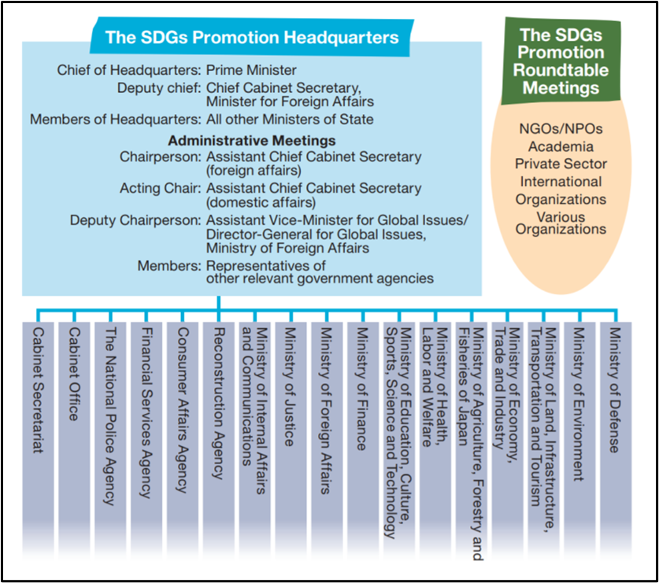

* + 1. **SDGs Promotion Round Table Meeting in the HQ**

To ensure the multi-stakeholder partnerships mentioned in target 17-16 and 17-17 of SDGs, theSDGs Promotion Round Table Meeting(Roundtable, hereafter) was set up in September 2016 within the SDGs HQ. This meeting has 14 members including 4 academicians, 3 from CSOs, 2 from the business sector, 2 from UN organizations, 1 each from the Japanese Trade Union Confederation (Rengo), the Network of Consumer Groups, and the Government Pension Investment Fund (GPIF). This meeting is supposed to take place, in principle, twice a year for 2 hours each, prior to the HQ’s semi-annual main meeting, to provide various ideas for SDGs policies and strategies.

**2-1-3.　Major Policies of the SDGs HQ**

1. **SDGs Implementation Guiding Principles**

In December 2016, “SDGs Implementation Guiding Principles”[7] (Principles, hereafter) was approved at the 2nd main meeting of SDGs HQ. These principles pledge that the GOJ would actively participate in the HLPF on the 2030 Agenda, submit a Voluntary National Report (VNR, hereafter) in 2017 and revise the principles every 4 years.

Based on SDGs’ 17 goals, the GOJ’s Principles declare 8 priority areas and policies as follows.

1. Empowerment of All People
2. Achievement of Good Health and Longevity
3. Creating Growth Market, Revitalization of Rural Areas, and Promoting Technological Innovation
4. Sustainable and Resilient Land Use, Promoting Quality Infrastructure
5. Energy Conservation, Renewable Energy, Climate Change Countermeasures, and Sound Material-Cycle Society
6. Conservation of Environment, including Biodiversity, Forests and Oceans
7. Achieving Peaceful, Safe and Secure Societies, and
8. Strengthening the Means and Frameworks of the Implementation of the SDGs

The Appendix Table[8] of this “Principles” provides us with details of each of the eight areas and policies, such as measures, related SDGs’ goal and target numbers, indicators and related governmental agencies. The total number of measures is as many as 140.

**Figure-2: Correlation of Japan’s Priority Areas with SDGs[9]**

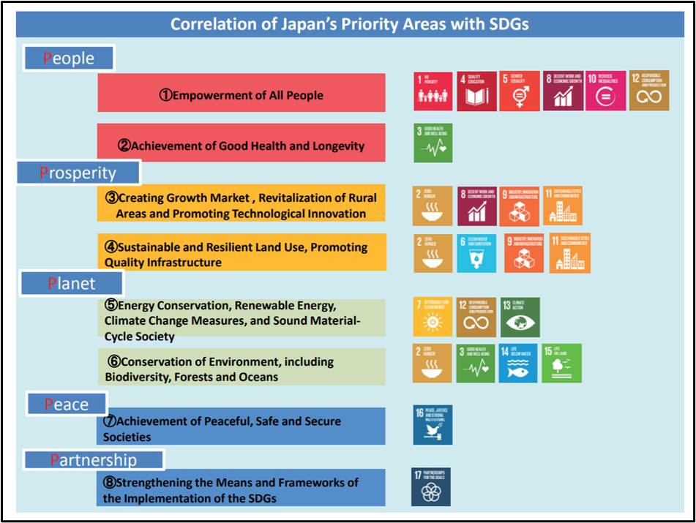

1. **Revised SDGs Implementation Guiding Principles**

As planned, at the 8th semi-annual main meeting of the SDGs HQ held in December 2019, the Principles were revised for the first time since their formulation in 2016.

Three days before the 8th Roundtable Meeting was held on Sept. 9, 2019 to discuss the draft revision of the Principles, a stakeholder meeting for the Principles was held on Sept. 6, 2019. This was called by a majority of the Round Table Meeting members, who felt intense frustration that its 8th meeting had only 2 hours to meet. This publicly open meeting was attended by MOFA high officials and a hundred plus people.

After the completion of the final draft of the revision, it was open for public comments for two weeks in Nov. 2019, and 303 comments were submitted. As the result, gender equality and the back-casting[10] approach for indicators were included in the revision, while poverty was not.

The revised Principles were officially approved by the 8th semi-annual main meeting of the SDGs HQ in Dec. 2019. There are no substantial changes except the aforementioned points in the main text of the Principles, but the Appendix Table, which provides details of the eight priority areas, policies and the responsible government agencies in the first Principles, has disappeared.

1. **Annual Action Plans and Annual Expanded Action Plans**

Since the SDGs HQ’s 4th main meeting in Dec. 2017, an annual Action Plan which details various ideas of the GOJ’s SDGs implementation in line with the Principles, has annually been adopted for the fiscal years following. In addition to this, since the SDGs HQ’s 5th meeting in June 2018, Expanded Action Plans are also adopted annually in order to reflect the GOJ’s annual budget situation for the on-going Action Plan.

Through the author’s comparative analysis of these 3 annual Action Plans for 2018, 2019 and 2020, the following features can be mentioned here.

1. All Action Plans emphasize the creation of the “SDGs Models of Japan” based on the eight priority areas and policies mentioned in the Principles. These models should be expanded internationally, especially to South East Asia and Africa, through various opportunities.
2. To create the SDGs Models, the following 3 pillars are always mentioned.

b-1. Promotion of “Society 5.0”[11] in connection with SDGs,

b-2. Regional revitalization and resilient, environmentally friendly and attractive community development based on SDGs, and

b-3. Empowerment of the next generation and women as SDGs implementers

c: Consistent and strong emphasis is given to technological innovation calling it as Society 5.0 in the b-1. The volume of content of b-1 is steadily increased. It is superfluous to mention that the idea of Society 5.0, originally proposed by Keidanren (Japan Business Federation, largest network of big companies) and imbedded in the SDGs HQ’s thoughts, is often criticized by some people and CSOs, as each of the previous paradigm shifts were accompanied by new and grave problems.

1. Similarly, contents of the above b-3’s “Empowerment of the next generations and women” are consistently increasing. It is extremely regrettable that the gender equity, included in the revised Principles at the end of 2019, is not mentioned in the 2020 Action Plan, although both of them were adopted at the same 8th HQ meeting.
2. Poverty and Income gap issues are thoroughly not mentioned, except some measures for child poverty in Japan. This is true of the three Action Plans as well as the original and the revised Principles.

**2-1-4.　Major Promotional Strategies and Actions of the SDGs HQ**

1. **GOJ’s National Voluntary Report (NVR, hereafter) in 2017**

As planned, the GOJ presented their NVR on the SDGs implementation at the

2017 HLPF in New York. Japan Civil Society Network on SDGs (SDGs Japan, hereafter) also distributed its counter report[12].

1. **Japan SDGs Awards**

From 2017, the SDGs HQ has annually conferred the Japan SDGs Awards to companies, local governments, schools, and NGOs/Non-profit Organizations (NPOs, hereafter) that are making outstanding efforts to promote a wide range of actions for sustainable development. Each time, 7~12 organizations are selected for this award by the Roundtable members.

1. **Next Generation Platform for SDGs Promotion**

In 2018, PM Abe, the chair of the SDGs HQ announced the establishment of the Next Generation Platform for SDGs Promotion at the HQ’s 5th main meeting. This Platform has a steering committee with eight youth organizations, such as the Junior Chamber (JC), Group 7/Group 20 Youth Japan and Japan Youth Platform for Sustainable Development (JYPS).

They actively participated in the ECOSOC’s Youth Forum held in New York in 2019 and organized a side event on Youth and SDGs with youth organizations from other countries. But since then, unlike the other Platform mentioned below, 2) of 3-2, this one has fallen rather dormant.

1. **Policies and Strategies of Concerned Ministries and National Public Institutions**

**3-1. Ministry of Foreign Affairs** (MOFA, hereafter)

Actually, MOFA’s Director General (DG, hereafter) for Global Issues is the focal person for SDGs implementation and coordination of the GOJ. The day-to-day work of the SDGs HQ is largely, if not almost all, carried out by the Global Issues Cooperation Division, one of five divisions under the DG.

For most of SDGs’ concerned organizations and persons including the SDGs Roundtable members, the prime contact person of GOJ relating to SDGs is not someone in the SDGs HQ in the Prime Minister’s Office, but the director of the MOFA division.

MOFA also maintains a webpage, namely the Japan SDGs Action Forum[13] that explains well what the SDGs HQ does.

* 1. **Cabinet Office (CAO, hereafter)**

The CAO and the Cabinet Secretariat, in which the SDGs HQ exists, are closely related to many important issues including regional revitalization, due to the population of Japan as a whole declining and aging. The CAO and the Cabinet Secretariat believe that SDGs are instrumental in dealing with domestic issues and thus propose the following projects.

1. **DGs Future City and Model Project**

Since 2018, the CAO along with the SDGs HQ annually select about thirty local governments as SDGs Future Cities and ten of these for grants-in-aid of up to 30 million yen (approx. $270,000) each for implementing respective model projects of SDGs.

1. **Government-Private Cooperation Platform for Regional Revitalization SDGs[14]**

The SDGs Government-Private Coordination Platform for Regional Revitalization was founded in 2018. As of Jan. 2020, this fee-free and government-run platform (the CAO with a think-tank company) has 1,161 organizational members, 61% of them private organizations, such as companies, NPOs, and educational/research institutes, and 38% local governments; and eleven GOJ’s ministries.

This platform has thirty-eight sub-committees each of which has a specific SDGs-related topic and one member as the leader. Some of them seem very active, whereas some are not.

The webpage of this platform exhibits fourteen SDGs-related challenges from twelve local governments seeking partner organizations to deal with those issues.

* 1. **Ministry of the Environment** (MOEJ, hereafter)

As Japan’s MOEJ claims that thirteen out of seventeen SDGs goals are closely related to environmental issues, this ministry, of all the GOJ’s ministries, seems to be the most eager for SDGs implementation. Unlike MOFA, where one DG and one division under the DG concentrate on SDGs, MOEJ’s a few bureaus and several divisions are working on that.

The MOEJ in cooperation with the Institute for Global Environmental Strategies (IGES) has organized own stakeholders’ meeting for SDGs implementation with sixteen members including seven from the business sector, four from GOJ, three academicians, and one each from a CSO and a local government. This meeting has been held ten times from Aug. 2016 to Nov. 2019 with over a hundred observers, mainly from the business sector, followed by social gatherings to get to know each other.

The MOEJ has issued a digital guidebook explaining how to apply SDGs for private companies, claiming that adaptation of SDGs would reduce management risks and increase business chances.

In addition, the Global Environment Outreach Centre (GEOC), an information center run jointly by the United Nations and the MOEJ, has organized a series of gatherings and introduced a number of books on SDGs, while the Japan Fund for Global Environment, a CSO funding mechanism utilizing the GOJ/MOEJ endowment and donations, has also started to emphasize SDGs in its funding and other events.

* 1. **Ministry of Education, Culture, Sports, Science and Technology** (MEXT, hereafter)

Similar to the MOEJ, the MEXT has also shown a very positive attitude toward SDGs by promoting Education for Sustainable Development (ESD, hereafter) as the SDGs’ Goal 4.

The ESD and the Decade of ESD from 2005 to 2015 were both proposed at the UN World Summit on Sustainable Development (WSSD) by the GOJ in 2002 and duly accepted. The MEXT and the Japan National Commission for UNESCO have digitally published a simple guidebook for EDS for UNESCO-associated schools in Japan as early as 2008.

In March 2018, the operation plan of the Global Action Program for ESD was adopted by the inter-ministerial meeting for ESD, for which secretaries of MEXT and MOEJ served as joint chairs. Based on this plan, a national ESD Resource Center of Japan and eight regional-wise the ESD Resource Centers have been founded in Tokyo to promote ESD and SDGs.

The new government course guidelines applied from FY 2020 for pre-primary, primary as well as middle education in Japan also mention that learners should become creators of a sustainable society.

* 1. **Ministry of Economy, Trade and Industry** (MITI, hereafter)

The MITI, one of the most powerful ministries of the GOJ, has also undertaken some SDGs initiatives for Japan’s economy. For instance, the ministry organized six study meetings on SDGs Management/ESG Investment[15] from Nov. 2018 to May 2019 and has digitally published the Report of Study Meetings on SDGs Management/ESG Investment[16] in June 2019. A month before this publication, MITI also digitally published the “The Guide for SDG Business Management”.[17] Furthermore the ministry, jointly with UNDP, held a tie-up event, called the “Joint Play-Up on MITI’s Guide for SDG Business Management and UNDP’s Innovative Finance and the SDGs”, in August 2019. All of above initiatives were carried out by the Industrial Finance Division of the Economic and Industrial Policy Bureau of the MITI.

* 1. **Ministry of Justice**

The Ministry of Justice also promotes SDG 16. They published “Commitment to the Sustainable Development Goals (SDGs) ” with their own SDGs Logo, which includes policies on prevention of adult and juvenile re-offending (Target 16.1 and 16.2), tackling issues of people without family registration (Target 16.9), promotion of preventive legal advice service (Target 16.3), international training courses and seminars for criminal justice practitioners, and legal technical assistance (Target 16.a), promoting the concept of being “Mental Barrier-Free” (Target 16.7 and 16.b), tackling children’s human rights issues with various communication tools (Target 16.2), improving comprehensive legal support (Target 16.3), and translation of Japanese laws (Target 16.3, 16.a and 16.b).

* 1. **Japan International Cooperation Agency** (JICA, hereafter)

JICA, the gigantic ODA implementation agency of the GOJ, issued a Position Paper on SDGs[18] on September 8, 2016. According to the paper, JICA pledged to play a central role in following ten SDGs goals; Goal 2, Hunger & Nutrition; Goal 3, Health; Goal 4, Education; Goal 6, Water and Sanitation; Goal 7, Energy; Goal 8, Economic Growth and Employment; Goal 9, Infrastructure and Industry; Goal 11, City; Goal 13, Climate Change; and Goal 15, Forests and Bio-Diversity.

Since JICA is merely an implementing organization, it has to follow superior policies and guidelines, such as GOJ’s Development Cooperation Charter adopted on Feb. 2015, the ODA prime policy calling quality growth beside human security, the Principles, and SDGs Action Plans.

It is therefore no wonder that this position paper does not emphasize the most important issues of SDGs, such as poverty & income gap, and gender equality. The excuse the JICA Paper gives is that Goal 1, Poverty; Goal 5, Gender Equality; Goal 10, Gap; and Goal 16, Peace & Governance are upper goals to be achieved through the above mentioned ten goals.

1. **Major Characteristics of the GOJ’s SDGs Implementation and Civil Society**

**4-1. Administration Centered Implementation**

In Japan, mainly administrative organs are working for SDGs implementation, in spite of the paragraph forty-five of the 2030 Agenda which acknowledges the essential role of national parliaments for SDGs. Most of the major political parties have expressed their interest in SDGs, but not enthusiastically enough to take concrete action beyond a few initiatives.

Although the SDGs HQ is located in the Prime Minister’s Office, symbolizing the whole-of-government approach, most of its work is carried out by the MOFA which is naturally weak in dealing with domestic issues and coordinating with other ministries.

**4-2. Cherry Picking**

Influential ministries and agencies of the GOJ have interpreted the SDGs as a useful tool for their original missions, such as ways to promote business and technical innovation, regional revitalization and so on. Most of these are more for economic development and less for social development.

As a result, some parts of the Principles, its revised form, and the annual Action Plans of SDGs seem cherry-picked by those ministries and agencies.

**4-3. Conservative Thoughts**

The GOJ, similar to its influential ministries, seems to utilize SDGs as a good chance to boost Japan up again, in terms of its economy, technology, regional and/or global influence in the face of a growing neighboring country and so on. The GOJ, therefore, does not seriously grapple with poverty and income gap issues, domestically or globally. That explains why the GOJ has no national definition of poverty as well as why JICA and Japan’s ODA have not prioritized goals addressing poverty and gaps.

As for the amount of Japan’s ODA, it is very certain that the GOJ will not strive to attain 0.7% of its GNI, Target 17-2 of SDGs, because it prioritizes domestic issues.

These nationalistic and conservative thoughts of the GOJ blocked the inclusion of “gender equality” in its Principles until Dec. 2019 but has yet to be included in its annual Action Plan. The GOJ will continue to promote coal fired power plants in and outside of Japan despite SDGs Goal 7, The Paris Agreement on Climate Change[19], SEforALL[20], and strong objections.

**4-4. Need of Advocacy by Civil Society**

SDGs, like campaign promises during elections, is not a binding agreement. All UN member countries are to strive to achieve SDGs’ Goals and Targets, but no more than that. The SDGs themselves allow national government flexibility to set its own goals and adopt different approaches, as mentioned in paragraphs fifty-five & fifty-nine of the 2030 Agenda. In other words, a government can intentionally or unintentionally interpret, if not distort, SDGs according to its convenience.

This is the very reason that NOGs and CSOs should play the role of watchdogs, advocating the implementation of the SDGs by their own government. In the case of Japan, the Japan Civil Society Network on SDGs (SDGs Japan[21]), founded in June 2016, continues its active advocacy for healthier implementation of SDGs in the spirit of NOLB.

(ends)

*Note: A part of this article is a part of JANIC (Japan NGO Network for International Cooperation)’s report “Narrative Report on the State of National Implementation of SDGs: Focus on SDG 16” issued in July 2020. This article has been submitted to the International Institute of Peace and Development Studies (IIPDS), a regional NGO based on Bangkok, Thailand for its anniversary publication in July 2020. The NGO has consented to use this with some revisions as my presentation at the SSF7.*

|  |  |
| --- | --- |
| Abbreviation List | |
| 2030 Agenda | 2030 Agenda for Sustainable Development |
| ADA | Asian Development Alliance |
| CAO | Cabinet Office |
| DG | Director General |
| ECOSOC | Economic and Social Council |
| ESD | Education for Sustainable Development |
| GOJ | Government of Japan |
| HLPF | UN High-Level Political Forum |
| IDPs | internally displace people |
| JICA | Japan International Cooperation Agency |
| MDGs | Millennium Development Goals |
| MEXT | Ministry of Education, Culture, Sports, Science and Technology |
| MITI | Ministry of Economy, Trade and Industry |
| MOEJ | Ministry of the Environment |
| MOFA | Ministry of Foreign Affairs |
| NOLB | No One Left Behind |
| NPOs | Non-profit Organizations |
| NVR | National Voluntary Report |
| ODA | Official Development Assistance |
| OWG | Open Working Group |
| Principles | SDGs Implementation Guiding Principles |
| Roundtable Meeting | SDGs Promotion Round Table Meeting |
| SDGs | Sustainable Development Goals |
| SDGs HQ | SDGs Promotion Headquarters |
| SDGs Japan | Japan Civil Society Network on SDGs |
| VNR | Voluntary National Report |

1. 5 Ps: People, Planet, Prosperity, Peace and Partnership.
2. A Guide to SDG Interactions: from Science to Implementation: https://council.science/publications/a-guide-to-sdg-interactions-from-science-to-implementation/
3. JANIC: Japan NGO Center for International Cooperation (JANIC) is the biggest network of NGO for international cooperation in Japan. https://www.janic.org/en/
4. ADA: http://ada2030.org/theme/koreapr/01/com01.php
5. Ise-Shima is a name of place famous for its natural marine scenery in the Mie Prefecture.
6. MOFA, p.7, https://www.mofa.go.jp/files/000287390.pdf
7. SDGs Implementation Guiding Principles 2016: <https://www.mofa.go.jp/mofaj/gaiko/oda/sdgs/pdf/000252819.pdf>
8. Appendix Table of the Guiding Principles: <https://www.mofa.go.jp/mofaj/gaiko/oda/sdgs/pdf/000241490.pdf>
9. MOFA, p.16, https://www.mofa.go.jp/files/000287390.pdf
10. Back-casting: a planning way which starts with defining a desirable situation at the end of a period and then works backwards to decide actions and steps at present, or near future, that will lead toward the specified future.
11. Society 5.0: https://www8.cao.go.jp/cstp/english/society5_0/index.html
12. SDGs Japan’s counter report (Analysis and Recommendations for Policy Priorities and Implementation Mechanism in Japan: <https://drive.google.com/file/d/0BxbtK2dVB113NkM5cFdpMjNTTEk/view>
13. Japan SDGs Action Forum: https://www.mofa.go.jp/policy/oda/sdgs/index.html
14. Government-Private Cooperation Platform for Regional Revitalization SDGs (in Japanese): <http://future-city.jp/platform/>

    For the Future City Initiative: <https://www.kantei.go.jp/jp/singi/tiiki/kankyo/en/about/index.html>
15. ESG Investment: An investing method that considers environmental, social and governance (ESG) factors.
16. MITI’s the Report of Study Meetings on SDGs Management/ESG Investment (in Japanese): <https://www.meti.go.jp/press/2019/06/20190628007/20190628007_01.pdf>
17. MITI’s The Guide for SDG Business Management (in Japanese): https://www.meti.go.jp/press/2019/05/20190531003/20190531003-4.pdf
18. JICA’s Position Paper on SDGs: <https://www.jica.go.jp/aboutoda/sdgs/ku57pq00002e2b2a-att/JICA_torikumi_e.pdf>
19. Paris Agreement on Climate Change: https://unfccc.int/process-and-meetings/the-paris-agreement/the-paris-agreement
20. SEforALL is an UN born international non-profit organization: https://www.seforall.org/about-us
21. SDGs Japan: https://www.sdgs-japan.net/en