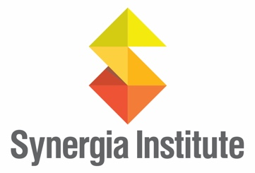

**Towards Co-operative Commonwealth: Transition in a Perilous Century Online Course – March 25**

**Overview**

Today, political, economic, social and ecological crises are deepening, putting life at risk on a global level. Many of us are working toward solutions, that are socially just and ecologically sound. Advocacy for a new economics is growing. But as calls for systems change grow we often work in silos, unaware of each other’s thinking, tools and strategies. Too often, we are missing opportunities to work together.

As practitioners and community educators looking to pool ideas, methods, and efforts, we’ve developed a MOOC—a place filled with contemporary content where like-minded people can come together to discuss and strategize systems change. And we want you to join us.

**Towards Co-operative Commonwealth** is a free, massive, open, online course offered by Synergia Institute with support from Athabasca University that sets out what effective systems change means, and the most promising ways to secure our communities' basic needs in increasingly difficult times. **It is a master class in *movement building* for a new model of political economy that is sustainable, democratic, socially just and based on the principles of co-operation and the common good.** It is suitable for newcomers to social change work as well as veteran activists, practitioners, policy-makers, students, and researchers. Individuals on their own and people working for social change through organizations, networks, and movements can use the course material and the accumulated expertise of the Synergia team, and that of fellow participants, to advance their own work.

**Course schedule and content**

**Segment 2 – Four Weeks starting May 20**

5. Democratizing Social Care: From Welfare State to Caring Society

6. Democratic Ownership: Pathways to a Resilient Energy Future

7.Democratic Financing Solutions for the Great Transition

8. Synthesis: Building the Politics for Systems Change

**Segment 1 – Four Weeks starting March 25**

1. Framing the Journey: Capitalism, Planetary Limits & The Struggle to Restore & Share our Common Wealth
2. Stewarding Land & Resources for the Common Good
3. Ecological Resilience and a Just Food System
4. Precarious Livelihoods: Pathways to Solidarity

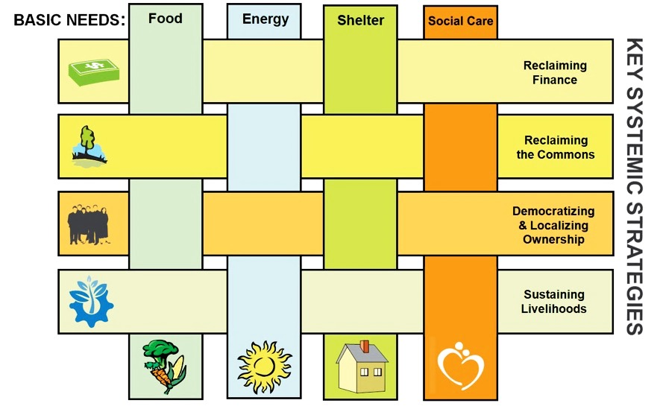

The eight course modules shape a unifying perspective based on key strategies for systemic change across a diverse range of solution-focused practices and models in key sectors. They weave together complementary themes of resistance aimed at protecting the common good and organizing aimed at regenerative solutions – both necessary prerequisites for advancing systems change.

Synergia Institute is offering this course as a vehicle for both individuals and groups to increase their knowledge, and to deepen their critical understanding and day-to-day practice for social change in ways that both draws from, and contributes to, a politics of change globally. This includes a mechanism for group study on specific issues, or the formation of action circles in which groups of like-minded people can adapt ideas, strategies, and technical expertise to further their work on local issues or common projects.

Following the course, the Synergia team of facilitators and specialists will remain available for three weeks to facilitate further discussion and feedback with participants and groups wishing to focus their synthesis work in Module 8 on applications to their local context or project. This will be at no cost.

A certificate of completion will be offered at the end of the course. We are also pursuing a graduate level credit for the course. This will be decided by the end of February.

For updates, follow Synergia on our Facebook page: <https://www.facebook.com/synergiainstitute/?ref=bookmarks>

Synergia website: <https://synergiainstitute.wordpress.com/>