El Che, Symbol of the Humanist and Socialist Struggle!
By: Joao Pedro Stedile / Source: Caros Amigos Magazine / September 17, 2017

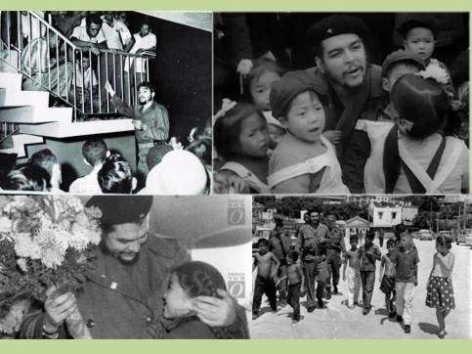

On October 9, 50 years since the murder of Che Guevera will be reached. He was arrested, wounded on October 8, 1967, and shot to death the next day in the external wall of a little rural school, at the town La Higuera, Valle Grande, Bolivia, by direct orders of the CIA.

I was there in the celebrations for the 40th anniversary. I could never understand how the Che Guevara entered those unpopulated mountains of 3 or 4 thousand meters, without any mass organization present to support him. Today, the place has stopped in time and the misery of the region is the same as always. Even with a popular government, we can determine that building an equal, fair, post capitalism society is a mission for decades of force accumulation by the organized people. It is not enough to reach the government, like left parties have thought.

The image of the Che and his legacy have always been really polemic and manipulated by left and right. To the left, the biggest havoc was the narration of the Frenchmen Regis Debray, who disseminated a book which resumes the ideas of the Che and mistakenly narrates the actions of a little group of timeless fighters that adopted the guerrilla tactics to defeat the oppressors.

In no country has happened that, least of all in the victory of the Cuban people in 1959.

The legacy of the Che is much more important and for that, 50 years after his murder, he is practically present in all the world and in every generation.

The Che was not an adventurer, a guerrilla fighter or a solitary hero.
The Che practiced coherently the ideas that he preached daily, as her daughter stated in a documentary. But besides coherence, his life experience has left us many examples to study and follow.

He always defended the importance of education, so that the youth, the militants, but essentially everybody, dominates the scientific knowledge, to resolve more quickly the people’s problems and having a more lucid and worthy life for everybody. He repeated to Marti, “Only knowledge can truly free people!”. He always defended simple life and sacrifice spirit among leaders. Being the first in the work line and the last in the benefit line. A practice that leaders from leftist parties have left behind years ago. He defended solidarity and internationalism. “It is necessary to get outraged by any injustice practiced against anybody, in any place of the world. If we defend this principle, then we are companions”, he replied to an Uruguayan comrade who asked if he was her companion.

He participated in the Cuban revolution and occupied every possible position: Commander of the Armed Forces, Minister, President of the Central Bank. And even so, he chose his missionary vocation and went to the Congo, in Africa, and then to Bolivia.

He helped to articulate countries and popular governments in an anti-imperialist front, which concluded in the articulation of the OSPAAL

In all his activities and gestures, he was always a humanist. And he saw socialism as a mean to achieve fairer, wiser and more equal opportunities.

He defended polemic ideas while constructing Cuban socialism, like promoting industrialization and political independence as the fastest way to solve the problems of the people.

He was only 39 years when he was murdered. But it seems like a lifetime of decades.
For all this, is that the right, the capitalist, devote so much hate to him, because they know that his legacy will keep influencing young people and workers. And one day his ideas and practices shall be hegemonic.

http://www.thedawn-news.org/2017/09/29/el-che-symbol-of-the-humanist-and-socialist-struggle/

