Landless Workers Movement of Brazil (MST)
Actions in Solidarity

During the pandemic, the MST has donated more than 1500 tons of food and has distributed more than seventy thousand lunchboxes. Fidel Castro often said, “solidarity is not giving what we have left, but sharing what we have.”

Click the link below, to see the actions that took place in 24 states: https://youtu.be/95hiYmgEw_g

Figure 1 - "Agrarian Reform, against impunity, and growing food to field and city". [MST archive]

Solidarity:

Solidarity actions are taking place at different levels of the MST: in settlements, in encampments, in collective spaces, in class-wide dialogues and individual solidarity actions.

In states throughout Brazil, solidarity actions grow in conjunction and as part of the campaign “Periferia Viva”, where the MST participates along with other social movements, as well as in the campaign “Vamos Precisar de Todo Mundo” organized by Frente Brasil Popular and Frente Povo Sem Medo. These actions have primarily been concentrated within the large urban centers.

The actions are quite diverse: food donations; food basket donations with agroecological produce; lunchbox donations; production and contribution of alcohol, hand sanitizer and soap; production of face masks, coat donation campaigns, book donations, among others.

Figure 2 - Rosemary (community in Pinhão-PR) solidarizes with donating food to families in vulnerable situation due to COVID-19". "As we were helped before, now we are able to help". [MST archive]

Solidarity, Battle of Ideas and Base work:

In the political practice of solidarity, we build actions of agitation and propaganda, formation and base work, based on the relationship with the communities who receive our food and visits. Thus, we found open doors to advance a political practice that can be synthesized in the following triad: Solidarity, Battle of Ideas and Base Work.

Our priority at this time is to save lives and defend our people from the virus and hunger, but at the same time contribute to the organization and political development of our class, by understanding solidarity as a revolutionary principle and as an organizational tool to harness the power of the people.

Within the national initiatives that we have helped to build in the Battle of Ideas, it is important to highlight the work of national political formation through virtual courses. This, along with the books that will be distributed by the publishing house, Editora Expressão Popular, serve as guides to understand and analyze the present moment, as well as to expand the knowledge of the militants who are involved in solidarity actions. Also, we have the challenge of massifying the distribution of accessible books to the people. In each basket, lunch box, soup plate, or distributed mask, we must also carry the mistica of book distribution.

Figure 3 - Food donation in a periphery of Santa Catarina state, South Brazil. [MST archive]

Health Collective:

It is worth highlighting the role of our health collective in the face of the Covid-19 pandemic. We realized that the precarious public health situation does not allow us to feel safe when seeking assistance. Our health collective brings together a set of guidelines as well as technical and political knowledge and an understanding of the totality of human health. The group has permanently accompanied the prevention and care of the mind and body and has joined the efforts of “our” doctors (yes, our doctors, as they are the fruits of our movement and our political articulations) who are serving, with dedication, all the people through their specific jobs, as well as accompanying our militancy.
Figure 4 - MST's Healthy Collective. [MST archive]

Solidarity Lunchboxes:

The action of distributing solidarity lunchboxes continues in our states, due to the performance of Armazéns do Campo (field warehouses). Some states have also carried out this action in a timely manner. This has resulted in the distribution of more than 50,000 solidarity lunchboxes.

This action has provoked ongoing reflection over people in situations of social vulnerability due to the lack of public policies and who, in this moment of crisis, are experiencing a very difficult situation of poverty in our country.
Figure 5 - Donation of lunchboxes at Armazém do Campo in Recife-PE, Northeast Brazil, by the youth of Levante (Popular Movement of Brazilian Youth). [MST archive]
Figure 6 - Preparation of meals to donation. [MST archive]

Donations of Agrarian Reform products:

Settlements and encampments have played a fundamental role in the production of food that has been distributed to the low-income population in large urban centers.

This action has allowed proximity to the reality of the periphery, making it possible to feel the anguish, the needs and the sad situation of the state’s daily violence against the communities.

Figure 7 - MST's communities collect food to donation. [MST archive]

Book Donations

Along with food, books are being distributed individually (along with the distribution of lunchboxes or food baskets) and collectively for the construction of popular libraries. There are books of different genres: children’s literature, classical literature, others related to nutrition, etc. We highlight how much this initiative has brought joy to those who receive the donation and, we emphasize the importance of ensuring people’s access to books. There is a demonstration of great joy when people who receive food donations also receive a book. We highlight the role of our publisher, Expressão Popular, during these actions.

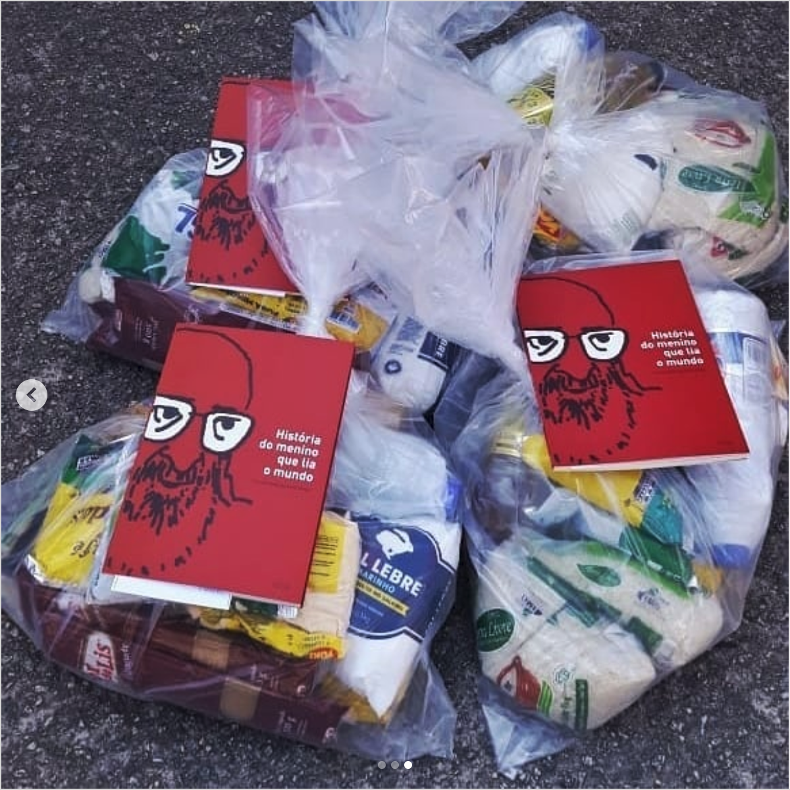
Figure 8 - Basic baskets with books ("Story of a boy who read the world") to donation. [MST archive]

Organization of Volunteers

The MST has also organized, through solidarity actions, a large number of volunteers who are at the disposal of the movement. These volunteers contribute to activities along with the families who are most in need. They are volunteers who work in the dissemination of MST actions, indirect donations, in fundraising campaigns, and also directly in cleaning, sanitizing, preparing and distributing food.

Figure 9 - Volunteers helping on food donation. [MST archive]

Other Campaigns:

In addition to food donations, the Periferia Viva campaign has also been involved in the production and distribution of masks. In some places, with the arrival of the falling temperatures, cold-weather clothing has been collected and health guidelines distributed through health professionals for the families that receive the donation from the MST.

Figure 10 - Preparing food donation. [MST archive]

