http://www.radicalecologicaldemocracy.org/a-path-to-freedom/
[This article appeared on the Radical Ecological Democracy website, 27 Sept 2017]

A Path To Freedom
September 27, 2017
By Gustavo Esteva
It is possible to say that underdevelopment afflicted me when I was 13 years old. On January 20, 1949 I became underdeveloped along with two billion other people of the non-western world, the former colonies, when president Truman took office and adopted the word as a political emblem of American hegemony.
But, we were not underdeveloped and we had our own ideas about how our societies should function and evolve. For Gandhi, for instance, Western civilization was a curable disease and he did not want to nationalize the British developmental model in independent India. Instead, he advocated for Hind Swaraj. Gandhi’s vision for India’s post-independence life was rooted in the values of frugality, minimum wastage, communitarian interdependence, the shunning of materialistic desire and respect for the eco-system. Similarly, Cárdenas, in Mexico, had closely observed the last capitalist crisis and was dreaming of a country of ejidos (communal land) and small industrial communities, electrified and with sanitation. He wanted technology to be used to reduce the toil on men and not for the so-called overproduction. We were trying to finally follow our own path after centuries of colonization.
To be “underdeveloped” is very humiliating. You can no longer trust your own nose or dream your own dreams. Moreover, “development” comes with the implied fascination for the other. American hegemony was universally recognized after the war. Cinema was its preferred tool and the American Way of Life depicted in the movies was something close to paradise. And, then, President Truman offered to share American scientific and technological advances for us to develop, to get all those goodies. It wasn’t just our leaders who wanted development; we all wanted it – for ourselves, for our families, for our countries. We wanted to dream the American Dream and to enjoy the American Way of Life, the new definition of the good life.
Development was the main postwar expression of the neocolonial ethos associated with the promotion of capitalism. It absorbed and reformulated all pre-capitalist modes of production through a very successful juxtaposition of physical and psychological forms of coercion, the simultaneous use of public force and of all the means of manipulation and education. The idolization of the American Way of Life played a central part, particularly when it was transformed into a universally sanctioned model of society.
Early Years
This unfolding narrative had an impact on my life, too. My father died when I was 16 years old. Forced to work for the sustenance of my family, I started as an office boy in a bank. Soon, I was offered the opportunity to be a part of the first generation of the emerging profession of business administration in Mexico. I had spectacular success and in short order occupied managerial positions in Procter & Gamble, IBM, other Mexican companies and finally my own professional bureau. But, I was increasingly uncomfortable with my career. I was not at the center of the epic of development, as promised, but on one side, and not the best side on top of that. I was fired from both Procter and IBM, because I refused to do what they instructed me to do: cheating the workers and the community. I was forced to abandon my profession when I was 24 years old. It was clear that I could not live a decent life in the corporate world.
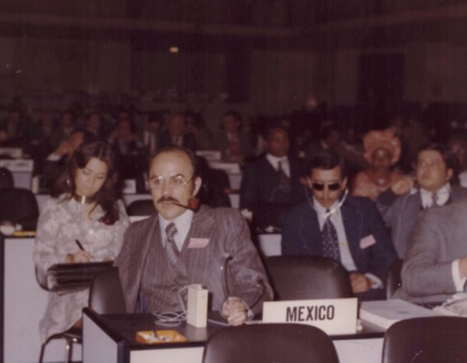
Gustavo Esteva representing Mexico at the 1974 FAO World Food Conference

Social movements in Mexico, and the triumphant arrival of Fidel in La Havana in 1959 attracted me to another path. I became a leftist, then a Marxist-Leninist and finally a would-be guerrilla-man. For us, in Latin America, Che Guevara was not only an icon and a moral imperative, but also the practical model to follow. My guerrilla project collapsed, however, in the very beginning itself, when one of our leaders killed another contender for leadership in a crime of passion and jealousy. We came face to face with the violence we were internalizing and wanted to impose on the rest of the society. That did not mean that we abandoned our dreams of development and revolution, but only the tools of an armed uprising. Since the purpose of the guerrilla was to seize the State, we entered the government.
In the early 70s, with a populist president at the helm, I acquired a lot of bureaucratic power in the Mexican government. I was organizing magnificent development programs, mobilizing millions of people, both, in the cities and the countryside. Given the success of those programs, I was in the immediate danger of becoming a minister for the new administration in 1976. Instead, I quit. By then, I knew at least two things: that development could be very damaging and that the State we were supposed to occupy for our revolution was a very violent tool of domination and control, and quite useless for achieving social justice and emancipation.
My story in the 70s illustrates the lesson we learned in those years around the world. We believed that the change we wanted was possible using the existing institutions and under the leadership of a few statesmen governing some of the key countries. The Trilateral Commission, a forceful representation of western hegemony, however, had different ideas and it ushered in the plans and policies later known as neoliberal globalization. As Chomsky said, the commission wanted to push “the people back to passivity and obedience so they didn’t put so many constraints on state power.” We were soundly beaten.
Rethinking Development
After quitting the government, I embarked upon my NGO career and collaborated with some friends to found grassroots organizations. In the beginning, we assumed that without bureaucratic interference the notion of development still had some meaning. After two or three years of listening to the people at the grassroots, we learned that they were interested in autonomy and decentralism, not in development.
In the 80s, “the lost decade for development in Latin America”, it became entirely evident that the conventional goals of development were unfeasible. We were all enraged about this awareness of being always at the end of the line. Some decided to join the ranks of the developed within their own underdeveloped countries. But, for many of us the new awareness was a revelation: it became clear that any universal notion of the good life is stupid and irrelevant, even if it were feasible; and that we still had our own, very diverse, definitions of what it means to live well. They were at odds with the dominant system, but clearly feasible.
In the 80s the environmental movement was at its peak and forced the institutional world to react. But, it did that in the usual way: a Commission was created and “sustainable development” was adopted as a new slogan. From the very beginning we saw that it was not to sustain nature and culture, but to sustain development, which was already a frayed flag. The Americans acknowledged this, too. In the same speech in which Truman coined underdevelopment he also declared the Cold War. In 1989, when it ended, they observed that the emblem through which they wanted to stabilize their hegemony in 1949 was no longer effective and thus conceived globalization.
Neoliberal globalization
Sustainable development was pretty effective in sweetening ‘environmentalism’. What started in the 70s, as the counterpoint to capitalism became another business opportunity: the ‘green economy’. The desire to contribute to save the planet became a series of “sensible” habits, such as producing less waste or reducing the use of cars. They were, however, just skirting the main issue of neoliberalism, but, then, that was the point. Ultimately, however, “green economy” merely ended up giving nourishment to the machine producing environmental degradation: global capitalism, corporate governance and militarism.
In the early 90s, some people saw neoliberal globalization as a promise and others viewed it as a threat. But, almost everyone saw it as a reality, a fact of life. People were trying to figure out their response to that worldwide development in various ways. The most unique and dynamic response came in the shape of the Zapatista uprising, on January 1st 1994. It was a wake-up call, recognized as such by all anti-systemic movements since then. The Zapatistas said ¡Basta! Enough! To the dominant system. They explained that the Fourth World War (Third World War being the cold war) had already started and it was not between countries but against the people. Since the mood of capitalism had shifted from production to dispossession, it needed to change the rules of the game, too. While the nation-state was the traditional arena for capitalist expansion, it had become an obstacle for transnational capital, which began to dissolve it.
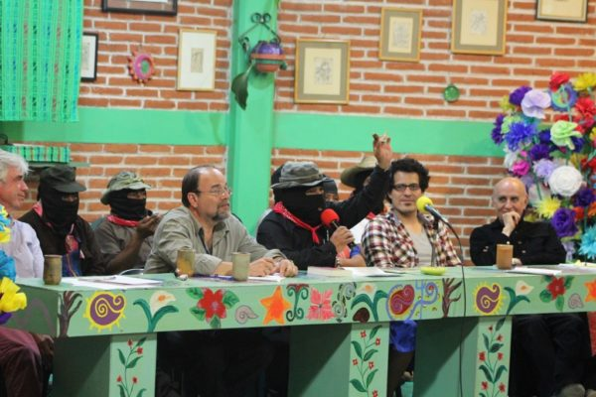
Gustavo Esteva participating in the Seminar “Critical Thinking Before the Capitalist Hydra”, convened by the Zapatistas at Universidad de la Tierra en Chiapas, San Cristóbal de Las Casas, Chiapas, México, 2015.
It had become obvious that the much-celebrated principles of law and democracy had gradually devolved to become political expediencies of capitalism. But, now, they had become an obstacle for dispossession, which requires instead a state of exception, and the use of public force, making them merely a democratic façade. And, frankly, it was only a façade. Greece, where the word was born, and the US, where democracy took its modern shape, were, both, built around the institution of slavery. The regime should, in fact, be called a ‘democratic despotism’, and its boundaries of color and gender preclusion fully recognized. The capitalist democracy is inherently racist and sexist.
Even that façade had become an inconvenience for capital and the governments at its service. For capitalism people were just labor force, whether actually or potentially. And, in the new condition of neoliberalism the number of disposable human beings kept increasing, as capitalism no longer had any use for them. In a way, transnational capital reproduces the technique of dispossession, which was a characteristic of ‘primitive accumulation’, in the tradition of the enclosure of the commons. But, it can no longer ensure the social relations that are necessary for the productive functioning of labor force. Modern technology gradually brought to a halt the cycle of perpetual transformation of labor force into capital and capital into labor force. That forced capitalism to reach its internal limit. And, now it also has to reckon with the flip side of the coin, which is that of the external limit posed by environmental degradation.
Twelve days after the Zapatista uprising the government was forced to declare a unilateral cease fire, which the revolutionaries have respected since then. They haven’t, in fact, used their weapons even for self-defense. I have been actively involved in the work of the Zapatistas. In 1995 they invited me to become one of their advisors in their negotiations with the government, and I was involved in the Agreements of San Andrés. When the government failed to honor its commitment, the Zapatistas decided to apply the provisions of that agreement in their own territory of about 250,000 hectares they had recovered with their own efforts. A law enacted by public pressure forced the government to formally respect that territory. It, however, never ceased to harass and attack the Zapatistas through paramilitaries, social programs and other tools.
The Zapatista Intervention
The Zapatistas probably represent the most radical political initiative in the world, and perhaps the most important one, too. They have fashioned an alternative society and a distinct kind of a human being in the area they control. Starting from scratch they’ve created a self-sufficient, autonomous way of life and government in one of the poorest areas of the world. They don’t accept any funds or services from the government. And, their operative model is clearly beyond the recognizable criteria of nation-state, capitalism, formal democracy and patriarchy. It is the best illustration of the ways in which people all around the world are replacing ‘development’ with myriad forms of living well. ‘Buen vivir’ (living well) is an expression adopted recently in South America, to allude to alternatives to development. It has even been incorporated into some national constitutions.
The development discourse still dominates the society – sometimes as savage capitalism, symbolized by an oil platform located at least 10km offshore, safe from harassment by local indigenous militants. Its other manifestation is as philanthropic capitalism, which stands for a chicken in every pot, a mosquito net over every bed, and a condom on every penis. But, the ‘development’ enterprise and its discourse have an increasingly dubious legitimacy and the socio-economic and political process it has laid out is even more anti-democratic than in the past. The Chomsky film, Requiem for the American Dream, illustrates a familiar experience. The myth of development no longer mobilizes the masses. Consequently, corporations and governments require more coercive force than ever before to implement development projects. “Dreamers” are still around, as many undocumented migrants are called in the US, and millions everywhere still look for the goodies of the American Way of Life. As Ivan Illich observed 50 years ago, in the consumer society the one who is not a prisoner of addiction is a prisoner of envy. But the current conditions of the world are limiting the number of addicts and offering them alternatives to envy.
I live in a small Zapotec village in Oaxaca, in the South of Mexico, where the majority of the population is indigenous. I enjoy a life of privilege at the top of a hill, next to a communal forest, where I cultivate most of my food. But, I also fit into six of the eight indicators, which specify the poverty line in Mexico. I have adopted forms of living well that are common in my social context but which clearly depart from any of the myriad definitions of development or the American Way of Life. I am active in the social movements in Oaxaca and in several organizations we have created with Indigenous peoples, like Unitierra Oaxaca, and I also participate in most of the initiatives periodically launched by the Zapatistas.
Charting a New Path
On December 21st, 2012 a silent march of 40,000 disciplined Zapatistas crossed through the cities they occupied during their armed uprising in 1994. At the end, they produced a short communiqué: “Did you listen? It’s the sound of your world collapsing. It’s the sound of ours reemerging. The day that was the day was actually the night. And night shall be the day, that shall be the day.”
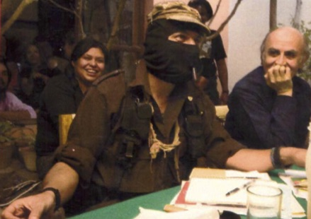
With Subcomandante Marcos, in Universidad de la Tierra en Oaxaca, during his stay in Oaxaca, Mexico, for “The Other Campaign”, a Zapatista initiative put forward as an alternative to the electoral circus.
Many other communiqués and initiatives followed, including seminars, artistic festivals and scientific gatherings. In October 2016 the Fifth Congress of the National Indian Congress (CNI) was held in Unitierra Chiapas, which became Zapatista territory. During that Congress the Zapatistas presented an analysis of the political situation and suggested that the time had come to take the initiative and start a national offensive to resist the capitalist onslaught on people and to work towards meaningful change. After consulting their communities, CNI announced the creation of the Indigenous Council of Government on January 1st, 2017. They decided that their speaker, an indigenous woman, would be registered as an independent candidate for the presidential election of 2018.
On May 28th, the assembly of CNI took the decision to peacefully dismantle the existing dominant regime. They announced the creation of a new government that would function on the basis of harmony, coexistence, coordinated collective efforts, and a sense of justice for all. It was committed to shun all relations of subordination and to promote convivial freedom and radical democracy at all levels – from families and communities, municipalities, regions, tribes, towns, and barrios, to the Indigenous Council of Government.
The directives adopted by the council are to be implemented through the coherent and simple application of the seven agreements of mandar obedeciendo (to command by obeying). That is why upon creating it there were no electoral promises to be heard. Nor were there any discussions on how to milk the public coffers. They will also not be hunting for votes to occupy the State apparatuses, or creating a parallel government of any sort. They will, however, confront the criminal “government” which undermines the people’s existence. And all this will take place not in a vacuum, but instead here, in the middle of mud and grime. The existing regime will be challenged on its own ground, with its own rules.
The initiative implies constituting a government and exercising political power without taking the path of arms or the ballot box and without coup d’etats. It would not be easy to dismantle what remains of the regime that is violently and chaotically falling apart. Nor would it be to learn how to self-govern from below. But that is where we are, beginning to “wake-up those who’re sleeping”, demonstrating the sense, the nature and the content of this new way of collective action in our practice and in our actions, without physical or electoral constraints.
All over the world the word “government” has become identified with groups of mafiosos operating corrupt and inept institutions at the service of capital as they try to impose their will through persuasion or manipulation, or by force; organizing the plunder, and administering injustice. “Democracy”, has become a despotic, racist and sexist regime that creates subjects inoculated by the illusion of the “vote.” Everywhere we call the ‘rule of law’ a regime in which laws are used to establish illegality and to guarantee impunity.
This is the reiterated experience of the Indigenous peoples. Enough! they said to all that when they conceived an alternative. The new regime of political relationships is still fragile and incomplete. But, it already exists; it is nothing more than the creative and contemporary projection, on an unprecedented scale, of what those who made it have been practicing for centuries.
On January 2017, to express the mood I felt in my world at the grassroots, I started a monthly virtual seminar with the participation of more than 30 collectives in six countries. “Other political horizons: beyond the nation-state, capitalism, formal democracy and patriarchy” is a space for our reflection. After three months of a radical critique of the dominant system, we started exploring the alternatives, not as a mere speculation, but through the careful examination of ongoing initiatives – “testing” their radicalism, analyzing how they are expressions of a new world, born in the womb of the old. The ultimate test is how they really are beyond patriarchy, the root of the dominant, oppressive, destructive system; how they define their struggle for life, against the deadly projects killing them.

Consolidating the Alternative
The time has come to listen to ordinary people. They are constructing a new world for sheer survival or in the name of old ideals. Capitalism cannot stop or revert its self-destruction. But that does not automatically imply an opportunity for emancipation. Instead, it could mean falling into barbarism…bringing all of us to an abyss. Survival of the human species depends now, as always, on rediscovering hope as a social force. That is what ordinary people are nourishing today with their extraordinary behavior. And hope, for them, is not the belief that something will happen in a certain way, but the conviction that something makes sense, whatever may happen.
Today, there may not be any room for optimism, but we can still be hopeful. Arundhati Roy is right: “Another world is not only possible, she is on her way. On a quiet day, I can hear her breathing.”

Gustavo Esteva is a grassroots activist, independent writer and public intellectual. He has authored more than 40 books and many essays and articles. Gustavo is a columnist for La Jornada and writes occasionally for The Guardian. He is also an advisor for the Zapatistas in their negotiations with the Mexican government. Gustavo lives in a small Indigenous village in Oaxaca, in Southern Mexico. He currently collaborates with Centro de Encuentros y Diálogos Interculturales and Universidad de la Tierra en Oaxaca.
Links
Commoning in the New Society
https://www.degrowth.info/wp-content/uploads/2015/08/3567.pdf
The society of the different (2005) Interview with Nic Paget-Clarke:
http://www.inmotionmagazine.com/global/gest_int_1.html
Development (1993):
http://shifter-magazine.com/wp-content/uploads/2015/09/wolfgang-sachs-the-development-dictionary-n-a-guide-to-knowledge-as-power-2nd-ed-2010-1.pdf

