**Bypassing the Dollar: The Rise of Alternate Currency Systems**

[Anuradha Chenoy](https://thewire.in/author/anuradha-chenoy)

In a bid to shield themselves from Trump’s erratic policies and the dollar's hegemony, countries are opting to trade in national currencies.

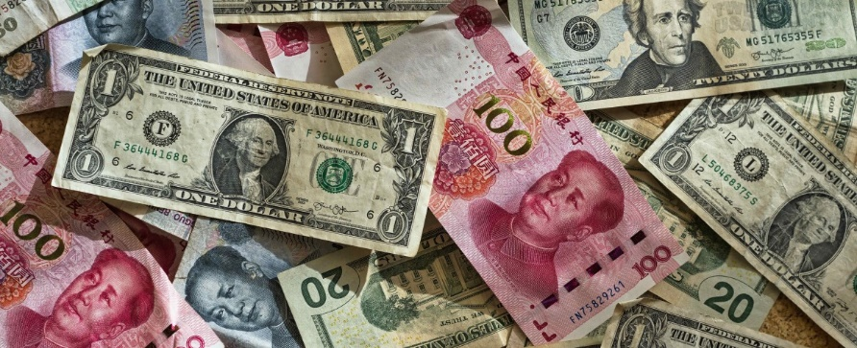

China is reducing its share in US treasury bonds and preparing for currency swap facilities. Photo: Eric Prouzet/Unsplash, (CC BY-SA)

25/MAY/2020

President Donald Trump, in recent times, has deeply weaponised the dollar in the midst of the coronavirus pandemic.

First metaphors were mixed when trade with China was labelled a ‘war’. There have been speculative attacks and unilateral sanctions placed on perceived threats and ‘enemy countries’. Retribution was expected since countries at the receiving end have been preparing to hit back.

This misuse of the dollar hegemony is not entirely new for the US but has deepened under the Trump administration.

Wars and retribution can have unexpected consequences. This time around, America’s geopolitical targets are preparing to shield themselves from the dollar hegemony. Procedures and plans are in process to bypass the dollar in international trade and use national currencies instead. These moves have picked momentum.

Russia and China have initiated [several measures](https://www.russia-briefing.com/news/russian-chinese-alternatives-swift-global-banking-network-coming-online.html/) like cross-border inter-bank payment systems parallel to the SWIFT. Both have increased gold holdings to back their currencies and initiated national currency swap agreements in several regional and bilateral arrangements where they play a role.

The March 2020 conference of finance ministers of the Shanghai Cooperation Organisation that includes China, Russia, Central Asian states, India and Pakistan [agreed to send recommendations](https://www.silkroadbriefing.com/news/2020/03/18/shanghai-cooperation-organisation-introduce-mutual-settlement-national-currencies-ditch-us-dollar/) finalising a roadmap to conduct bilateral trade, investments, mutual settlements and issue bonds in national currencies. This system is being expedited after US actions during the pandemic.

The BRICS’s New Development Bank, proposed disbursements in national currencies in 2015. In the April 2020 annual board of governors meeting with BRICS finance ministers, president of the bank K.V. Kamath said that in 2019, a quarter of the USD 15 billion of financial assistance was given in local currencies. Kamath [said](https://www.ndb.int/president_desk/speech-mr-k-v-kamath-president-new-development-bank-fifth-annual-meeting-board-governors/) that BRICS had no intention of destabilising the dollar but  “50 per cent (of projects) should be local currency financed”.

This is but another step that emerging economies have taken to show their play in the international system. The BRICS countries appear [committed](https://news.cgtn.com/news/2019-11-15/Russia-says-BRICS-countries-favor-idea-of-common-payment-system-LDj1tGjDLq/index.html) to trading in national currencies.

China is reducing its share in US treasury bonds and preparing for currency swap facilities as part of the Belt and Road Initiative (BRI) and in the Regional Comprehensive Economic Partnership with South-East Asian countries. Most of the ASEAN countries are ready for this.

Russia, previously a top holder of US sovereign debt, has radically decreased its holdings because of sanctions. Russia’s strategic relations with China deepened after the 2014 partnership and energy centred agreements. In 2017, Ruble-Yuan ‘payment versus payment’ started along the BRI. In 2019, the two countries [switched](https://www.russia-briefing.com/news/russia-china-sign-deal-settle-trade-respective-currencies-drop-bilateral-use-us-dollars.html/) to the Yuan RMB and Ruble exchange for their USD 25 billion trade.

Russia is pushing for currency swap agreements with various trade partners. The Eurasian Economic Union with Armenia, Belarus, Kazakhstan, Kyrgyzstan, and Russia comprises of the ‘road’ part of the BRI. With a population of 183 million and GDP of some US$ 5 trillion, [70%  of its trade](https://www.russia-briefing.com/news/eurasian-economic-union-de-dollarizes-70-2018-trade.html/) is in Rubles and local currencies. Several Central and West Asian countries want to join this union and Vietnam already has a full trade agreement with them. This saves the exchange charges of the dollar.

Trump used [sanctions](https://www.nytimes.com/2020/02/18/world/americas/venezuela-russia-sanctions-trump.html?auth=linked-google1tap) and stopped Russian companies like Rusal Aluminium from accessing the dollar-based financial system in 2017 and then on Rosneft Oil in 2020. Since then the US has over 30 active financial-and trade sanctions that cut access to the Federal Reserve that have had severely de-stabilised and [targeted weaker economies](https://www.investopedia.com/financial-edge/0410/countries-sanctioned-by-the-u.s.---and-why.aspx) like Iran, Iraq and Venezuela. The Trump administration tried to pressurise the IMF not to assist Iran for COVID relief package.

The consequence is that all these countries have established linkages with China and Russia for trade and economic sustainability. Russia is selling Venezuela’s crude oil. China diverted Iranian crude with Yuan payments and initiated the Iran-China silk route agreements. China is now Iran’s largest trade partner. Iran has diversified trade with Afghanistan and oil for gold with India.

Russia revived trade in national currencies that they was earlier used during the Soviet period within the communist bloc and with India. This exchange ended with the disintegration of the Soviet Union. In 2019, Delhi switched again to [Ruble payments for Russian S-400 defence systems](https://www.hindustantimes.com/india-news/s-400-delivery-on-track-india-makes-850-million-payment/story-HkMi2aZHTOklUGVb2xaoYO.html) because of US sanctions on Moscow.

India has worked out local currency trade with the UAE, approved USD 75 billion currency swap with Japan and USD 400 million currency swap with South Asian countries. India notified non-dollar mediated rates of exchange for Turkish and Korean currencies. Turkey is trading in national currencies with China and Russia. Now Russia proposes trade in Euros with the EU.

China is [internationalising the Yuan RMB](https://global.chinadaily.com.cn/a/201901/02/WS5c2c2a45a310d912140520d8.html) which is included in IMF basket, has risen to fifth place as global currency and represents 15% of global currency holding. Russia has 25% of Chinese RMB international reserves. Of course, the problem remains that the Yuan is not deep, open and liquid enough for financial markets. At the same time, most countries would not want the Yuan to become a mirror image of the dollar in its ability to manipulate financial sectors. So currency will be diversified with no currency maintaining complete hegemony.

Financial markets are complex and the US dollar is still the preferred currency. But countries have followed the contradictions within Trump’s policies – like raising debt ceilings to sustain the dollar as a global currency and even concealing lending to certain foreign banks – and have decided they need to protect themselves from this militarized dollar.

Trump’s marshal approach threatens others as well as the US and has hastened the rise of alternate currency systems. The US appears to be swiping at its nose to spite its face. Meanwhile the Chinese aphorism “hide your capability and bide your time” is clearly popular in much of Eurasia’s national currency transitions.

*Anuradha Chenoy is the former dean at School of International Studies, Jawaharlal Nehru University, New Delhi.*

<https://thewire.in/trade/dollar-currency-trade>