Che Guevara’s daughter reminds us of the reasons behind his revolutionary struggle
By: Aleida Guevara March / The Dawn News / September 26, 2017
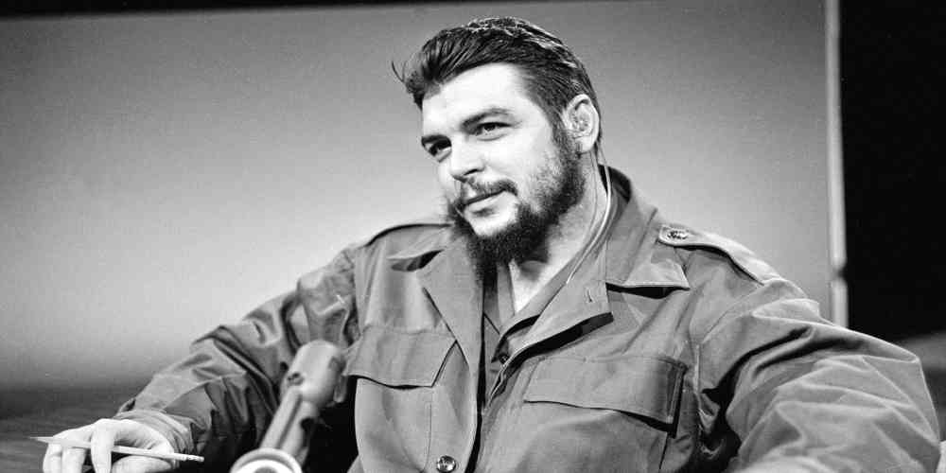Photo credit: Politico Scope
In order to speak about the Che Guevara we need time and space, but in order to explain his existence in our times we just need to look around us. If we ask what he was fighting for, the immediate answer is: for a better world. But what does this mean? Decent houses for everyone, free and high-quality education in equal conditions, accessible healthcare for all of the population, peace that would enable us to destine the available resources to research how to have better life. But, what do we really have?
To Che Guevara, youth is the clay with which we can model the New Man. But, what are we actually doing to youth? What kind of life are we offering them? What example are we setting for them? Who can inspire them to perfect their conduct? These are many questions and there are practically no answers—at least not the answers that youth need.
He said: “How long will we continue to have this order that is based on an absurd sense of caste—that is a question I can’t answer, but it is time for our rulers to dedicate less time to propagandizing their virtues as a regime and destine more money—much, much more money—to fund works for the benefit of society”.
What do you think about that? We could say the same thing to many rulers who do a bad job at governing many of our peoples, to begin with.
“… but those people who tackle things head on, who lead by example—to follow or to get others to follow you is a difficult task at times, but it is enormously easier than to push other to get them walking…”
Where do we want to go? What do we need? If we don’t fight for what we need, who will do it for us? It is undeniable that we have strength and courage, but we need unity, we need to organize that strength in order to conquer what we need to modify what doesn’t work, at least for the majority of the people.
“… to be quintessentially human, to be so human that we approach the best qualities of humanity, to purify what’s best in mankind through work, study, the exercise of continuous solidarity with the people and with all the peoples in the world…”
“… to develop sensibility to the maximum, to the point that we feel distressed when a man is killed in any corner of the world, and to feel enthusiasm when in any corner of the world a new flag of freedom is risen”.
That’s what we want for our youth, and it is very important to keep it in mind it now that we’re raising our voices to claim for the life of a young man like Santiago Maldonado, who recently disappeared in Argentina for being on the side of the Mapuche people and defending their rights. What message are they trying to send with the forced disapparition of this young man? Fear, that’s what they want us to feel in order to paralyze us, to silence us.
I remember the first time I was in Brazil. Imagine this young woman arriving in Sao Paulo and being told to not roll down the window of the car she’s travelling in, who feels fear for her driver whenever the car has to make a stop at a corner, which is when they assault you, who sees the eyes of a child high on drugs asking for something to eat—my reaction was immediate and I repeat what I said back then: it is better to die trying to change that reality than to avoid dying of hunger. But then I remembered that I come from a different culture, a different people, where the life of a human being, and especially of a child, is sacred, it is the most important thing. I thought I was reacting like this because I am Cuban, and I was raised by the socialist Revolution that we have, but I was wrong. Later on in my journey I met Mrs. Rosa, in Rio Grande do Sul. She’s a member of the Landless People’s Movement of Brazil. This humble peasant not only said what I was thinking, but she died defending a piece of land with which to feed her children. Mrs. Rosa proved to me that we indeed can and must fight for that better world, no matter where we come from, or which culture we carry with us—what matters and what prevails is the need to live.
“Let me tell you, at the risk of sounding ridiculous, that the true revolutionary is guided by great feelings of love. It is impossible to think of a true revolutionary without this virtue” .
A virtue that is indispensable to be able to give our best for a just cause, even risking our lives. I truly believe in this and I have seen it in the dedication of many men and women, luckily, in many parts of the world.
“And we, the exploited of the world, what role do we play? The peoples of three continents are watching and learning their lesson from Vietnam. Because, with the threat of war, imperialists blackmail the entire humanity: not fearing war is the right answer”.
“Under the slogan ‘We Won’t Allow Another Cuba’ there’s a hidden possibility of widespread aggressions, such as the one perpetrated against Dominican Republic or, previously, the Panama massacre, and the clear sign that yankee troops are willing to intervene anywhere in Latin America where the established order is altered and their interests are threatened”.
“This policy has almost absolute impunity: the OAS is a comfortable mask, however discredited; the UN has a degree of incompetence that borders ridicule or tragedy; the armies of every country in Latin America are ready to intervene to crush their peoples. The internationale of crime and betrayal has been formed de facto”.
Luckily for us, it is not like that anymore for all the peoples, but unfortunately in many the army is still a tool to crush the just claims of our people and one wonders where these men come from, who attack their own people. We’ve seen pictures of these uniformed men repressing demonstrations, attacking youth, women and even children without vacillation, and what do the Magna Cartas say about this? Because I know for a fact that many of them state that the army exists to defend the people and what happens in fact is exactly the opposite—so, whose side is violating the law?
When reading the Che’s words today, 50 years after his death, many things still resonate with what we see day to day, the relevance of his thoughts is strong and we should turn to him for answers more often.
There’s plenty to do, and the road is long and difficult, but we can and we must change many things to achieve the full dignity that human beings require in order to live. I always remember something that an Argentine mother had written on the tombstone of her daughter when she found her remains: “if I die, don’t cry for me; do what I did and in you I’ll live”. That is exactly what we owe to the men and women who have given their strength to us through their example, and encourage us to take action. Go on comrades, let’s live in such a way that, when our days come to an end, we don’t feel pain for the years that passed in vain, let’s feel the joy of leaving something beautiful for those to come.
Until Victory Always!

