NATURE MAY 27, 2021
FUTURE OF PLANETARY AND PEOPLE’S HEALTH
A reflection on why we must avoid fake food, fake science, face economics which puts profits above people and planet
By Dr Vandana Shiva

The Health and Climate Emergency are interconnected: Their common roots are an energy intensive, chemical intensive corporate controlled globalized food system that puts profits above people and planet.
We are living in the midst of a major public health emergency, as well as a Climate emergency.
296,000 people have died in India due to Covid 19. Last year Cyclone Amphan, this year cyclone Tauktae on the West Coast, and Cyclone Yaas in the Bay of Bengal have taken hundreds of lives.
Both the health disaster and the climate disaster are interconnected. We are part of the Earth, not separate from her. We are not her masters and manipulators.
The rich and powerful who see themselves as masters of nature do not respect planetary boundaries and ecosystems limits. They violate the intrinsic value of species and ecosystem, and ecological processes through the planet and people maintain their health. Their limitless greed that respects no limits has given us both the health emergency and the climate emergency.
A small group of global corporations have designed food systems for maximizing extraction of profits that destroy people’s health and the planets health.
The western corporate food system is designed for creating disease and climate change as externalities of profit maximization.
This toxic industrial food system is contributing to hunger, malnutrition, epidemics and chronic disease. Large scale Industrial globalised agriculture is producing nutritionally empty toxic ‘food’ commodities. Commodities do not feed people. 90% of corn and soya goes to biofuel and animal feed.
Intensive industrial agriculture is creating a health crisis, by producing nutritionally empty toxic commodities. More than 2 billion people suffer from food related diseases.
Industrial agriculture and ultra processed food contributes to 75% of food related chronic diseases.
Source: https://navdanyainternational.org/wp-content/ uploads/2019/01/Manifesto-Food-for-Health-Cibo-per-la- Salute.pdf
https://pubmed.ncbi.nlm.nih.gov/32761763/
Most chronic diseases are related to chemicals in food and to ultraprocessed food. They damage our gut microme which needs chemical free, diverse foods in the diet. Roundup Resistant soya bean has increased the use of Roundup which is destroying biodiversity of plants and pollinators and also the biodiversity in the gut microbiome.
Pandemics also have their roots in the limitless expansion into forests by agribusiness to grow commodities like GMO soya. Ebola, Zika, HIV, SARS … are among the 300 new infectious diseases that have emerged in the last 3 decades as forest ecosystems have given way to large agribusiness agriculture like GMO soya in the Amazon and palm oil in Indonesia.
Climate change is a result of fossil fuel based industrial production.
The rich countries and rich people are responsible for most of the pollution driving climate change.
Oxfam’s new report, ‘Confronting Carbon Inequality assesses that during the past three decades of globalisation and unprecedented emissions growth the richest one percent of the world’s population contributed more than twice as much carbon pollution as the 3.1 billion people who made up the poorest half of humanity during a critical 25-year period of unprecedented emissions growth.
https://www.theguardian.com/environment/2020/sep/21/worlds-richest-1-cause-double-co2-emissions-of-poorest-50-says-oxfam
https://www.oxfam.org/en/press-releases/carbon-emissions-richest-1-percent-more-double-emissions-poorest-half-humanity
A study authored by Jason Hickel, published in the ‘Lancet: Planetary Health’ shows that rich countries have violated their carbon space and are the biggest polluters. As of 2015, the USA was responsible for 40% of excess global CO2 emissions, EU was responsible for 29%, the G8 group of rich countries accounted for 85% of the excess, the global north accounted for 90%
https://www.thelancet.com/journals/lanplh/article/PIIS2542-5196(20)30196-0/fulltext
https://inthesetimes.com/article/climate-change-wealthy-western-nations-global-north-south-fires-west
Fossil fuel intensive, chemical intensive, industrial globalized agriculture is responsible for 50% of the Green house gas emissions.
11-15% from Agricultural production, 15-18% from deforestation, 15-20% from processing and long distance transport through global supply chains ,2-4% waste.
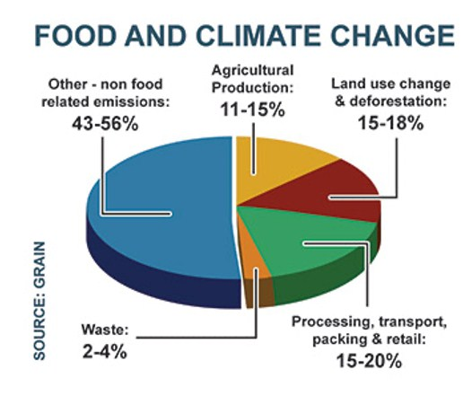
Contrary to the myth that small farmers and their agroecological systems are unproductive and should be wiped out, and we should leave the future of our food in the hands of global corporations to increase agricultural productivity and food production, industrial agriculture produces only 20 % of the food we eat, using 75% of the land. In reality small farmers are providing 80% of the food we eat, using just 25% of the resources that go into agriculture.
Source: http://www.fao.org/3/a-i4036e.odf
Source: https://climateandcapitalism.com/2018/01/07/ who-will-feed-world-industrial-ag-or-peasant-food-webs/
Not only does industrial agriculture use 75% of the land, it has destroyed 75% of the soil, water, biodiversity.
At this rate, if the share of industrial agriculture and industrial food in our diet is increased from 20% to 30%, we will have a dead planet, one with no life and no food.
On the other hand, the small ecological farms are providing 80% of the food today. They can provide 100% of the food tomorrow by regenerating the soil biodiversity and water, the climate system, and public health.

Land Used by Industrial Agriculture
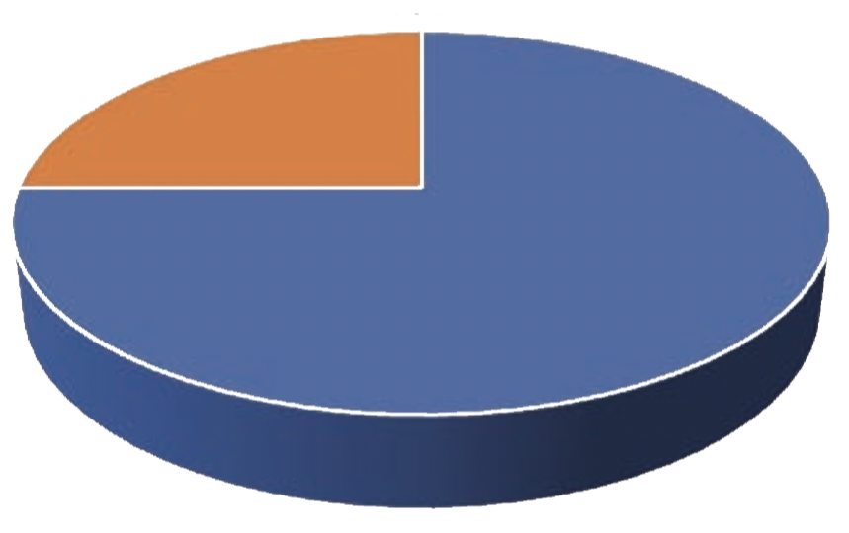
n land used by industrial agriculture
n land not used by industrial agriculture
Industrial Agriculture uses 75% of the land
Food Produced by Biodiverse Farms
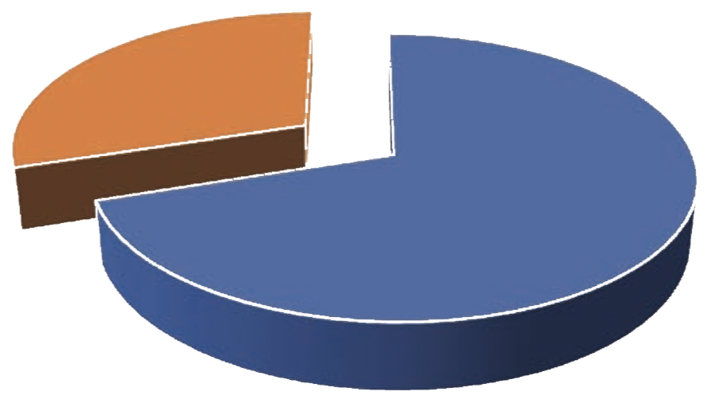
n land used by industrial agriculture
n food not produced by biodiverse farms
Biodiverse farms produce 80% of the food

What is needed to address the Climate Emergency and Public Health Emergency is protection of biodiversity of our plant and animal diversity to provide biodiverse food for maintaining a healthy gut microbiome, protection of small farms and small dairy which conserve and use biodiversity, are less dependent on costly toxic external inputs, are more productive in energy use and production of healthy, nutritious food. We need to strengthen our food sovereignty at local, regional and national level so that both planet and people are healthy . This is One Health.
However even as industrial agriculture brings the planet and our economies to collapse, the giant corporations and Big tech which have caused the crises are now seeking to control our food system by destroying our biodiversity and the livelihoods of our small farmers and livestock keepers by falsely blaming animals for climate change and trying to destroy our small farms.
We are witnessing a massive assault on small farmers and small livestock keepers by Big Ag combining with Big Tech.
“Plant Based” Fake Foods Based on Roundup Sprayed GMO Soya is destroying Biodiversity of forests, farms, plants and insects.
The fig leaf of “plant-based diet” is being used to continue to destroy the health of the planet and people through chemical intensive GMO soya.
Roundup Sprayed GMO soya grown by destroying the Amazon, Argentina or the US farmlands is “plant based”, but it is devastating for the planet’s and people’s health as can be witnessed by the deliberate burning of the Amazon, the world’s lungs. Destruction of forests like the Amazon is not just contributing to the Climate Emergency but also to Pandemics and the Health Emergency.
Source: https://www.bbc.com/news/world-latin america-49971563
https://www.theguardian.com/world/2020/jul/06/coronavirus-world-treating-symptoms-not-cause-pandemics-un-report
Deforestation for Agribusiness, including GMO soya, is responsible for 20% of the Greenhouse gas emissions.
There is a promotion of lab made hyperprocessed fake food (Plant based) as a climate solution.
In a recent article, “How our commitment to consumers and our planet led us to use GM soy” Pat Brown, CEO & Founder of Impossible Foods states that: “We sought the safest and most environmentally responsible option that would allow us to scale our production and provide the Impossible Burger to consumers at a reasonable cost”.
Source: https://medium.com/impossible-foods/how-our- commitment-to-consumers-and-our-planet-led-us-to- use-gm-soy-23f880c93408
Source: https://www.cnet.com/news/where-to-buy-the- impossible-burger-2-0-fast-food-and-chain-restaurants/
Given the fact that 90% of the monarch butterflies have disappeared due to Roundup Ready Crops, and we are living through what scientists have called an “insectageddon”, using GMO soya is hardly an “environmentally responsible option”.
Roundup sprayed GMO soya has already caused massive ecological devastation.
GMO Soya is a threat to the health of the planet and people, it cannot be the solution to climate change and the health emergency.
“Plant Based” Fake Foods Based on Roundup Sprayed GMO Soya increase the risk of cancer.
Roundup is a known carcinogen.
Recent court cases have affirmed the links of Roundup to cancer. The latest count of Glyphosate linked cancer cases against Bayer, which bought Monsanto, the maker of Roundup is 125,00 in the USA.
https://www.reuters.com/article/bayer-lawsuit-idUSL1N2GC163
Source: https://amp.rappler.com/business/236648-bayer- glyphosate-cases-usa?__twitter_impression=true

Bayer has lost cases, including appeals.
https://news.bloomberglaw.com/environment-and-energy/monsanto-review-bid-rejected-in-california-roundup-case
https://www.reuters.com/article/bayer-lawsuit-idUSL1N2GC163

With the build-up of liabilities related to cancer cases, the investments in Roundup Ready GMO soya ‘Plant based” products is not just irresponsibility towards people’s health, it is also blindness to the market.
Source: https://www.wsj.com/articles/bayers-roundup- woes-send-investors-fleeing-11558266059?mod=hp_ lead_pos3

At a time when across the world the movement to ban GMOs and Roundup is growing, promoting GMO soya as Plant Based “fake meat” is misleading the eater both in terms of the ontology of the burger and on claims of safety.
Impossible Burger has been nicknamed the “Cancer Burger”
Zen Honeycutt and Moms across America had the Impossible Burger tested. They said, “We are shocked to find that the Impossible Burger can have up to 11X higher levels of glyphosate residues than the Beyond Meat Burger according to these samples tested. This new product is being marketed as a solution for “healthy” eating, when in fact 11 ppb of glyphosate herbicide consumption can be highly dangerous. Only 0.1 ppb of glyphosate has been shown to destroy gut bacteria, which is where the stronghold of the immune system lies. I am gravely concerned that consumers are being misled to believe the Impossible Burger is healthy.”
Source:
https://www.momsacrossamerica.com/gmo_impossible_burger_positive_for_carcinogenic_glyphosate; https://d3n8a8pro7vhmx.cloudfront.net/yesmaam/pages/8069/attachments/original/1557958339/ COA_S0004900_Impossible_Burger_and_Beyond_Meat_ patty_-_glyphosate.pdf?1557958339

“Plant based meat” is a false phrase at every level.
There is an ontological confusion related to fake food. While claiming to get away from meat through “plant based” food, “fake meat” is about selling meat-like products. The Lab made ingredients have not been tested for safety.
Pat Brown declares, “we use genetically engineered yeast to produce heme, the “magic” molecule that makes meat taste like meat—and makes the Impossible Burger the only plant-based product to deliver the delicious explosion of flavor and aroma that meat- eating consumers crave.”
Source: https://impossiblefoods.com/heme/
I had thought that the plant-based diet was for vegans and vegetarians, not meat lovers.
The gold rush to lab made “plant based” substitutes for real food is about profits, not about the plant and people.
The “plant based” economic gold rush is about profits, not about care for the planet and people, for the plants and animals that feed us, the livelihoods of our small farmers and small dairy who are our Annadatas.
Pat Brown of Impossible Food declares, “If there’s one thing that we know, it’s that when an ancient unimprovable technology counters a better technology that is continuously improvable, it’s just a matter of time before the game is over.” He added, “I think our investors see this as a $3 trillion opportunity.”
Source: https://www.vegantradejournal.com/vegan-meat-industry-worth-3-trillion-to-overtake-prehistoric- animal-meat-sector/
Animals are sentient beings, not an “unimprovable technology”. In our culture, the cow is our mother, our Gau Mata.
There are 14 patents linked to Impossible Burger.
https://mimicnews.com/14-patents-in-every-fake-bite-of-impossible-burger
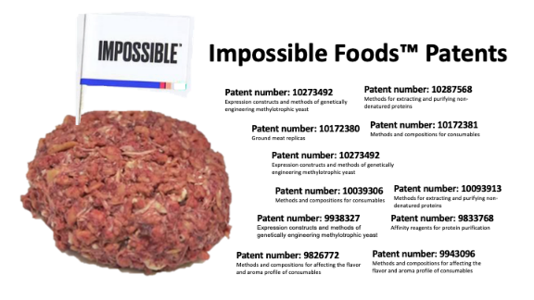
https://sethitzkan.medium.com/opinion-software-to-swallow-impossible-foods-should-be-called-impossible-patents-71805ecec9de

Among the new players pushing the Fake Food agenda are Companies including Beyond Meat and Impossible Foods, and even traditional meat producers including Tyson Foods Inc, Maple Leaf Foods Inc and Perdue Farms.
Source: https://in.reuters.com/finance/stocks/overview/ BYND.O; https://in.reuters.com/finance/stocks/overview/ TSN.N; https://in.reuters.com/finance/stocks/overview/MFI.TO

Big Tech is also investing in Fake Food/Lab Food/Synthetic Food
“Synthetic Biology involves reconfiguring the DNA of an organism to create something entirely new, allowing for limitless applications in multiple fields, such as “fake meat” and other “fake foods”, to agriculture, to new engineered raw materials, and pharmaceuticals.
Among the largest investors in this sector is Microsoft founder Bill Gates. His early investments include Beyond Meat, Ginkgo Bioworks - which is developing custom-built microbes - as well as Pivot Bio, a biotech start-up that focuses on making nitrogen fixing microbes.
Eric Schmidt, co-founder of Google has invested in several synthetic biology companies through early-stage venture capital firm Innovation Endeavours. His synthetic biology portfolio includes Zymergen, Bolt Threads, GRO Biosciences, and Ukko.
Peter Thiel, co-founder of PayPal, Palantir Technologies, and Founders Fund, a world-renowned VC firm and, also, the first investor in Facebook, has invested along with Schmidt in Bolt Threads, and is also backing Synthego and Emerald Cloud Lab.
Marc Andreessen, founder of Netscape and Andreessen Horowitz invested in Benchling — a company that offers tools to engineer DNA digitally.
Other high-profile investors in synthetic biology include Vinod Khosla (Sun Microsystems), Jerry Yang (Yahoo!), Bryan Johnson (Venmo), and Max Levchin (PayPal)[1].
The chronic disease epidemic is related to eating ultraprocessed, toxic uniformity Hyperprocessed lab food will do more harm to our microbiome with 100 trillion microbes which need diversity of chemical free real food to provide us nourishment and create a healthy robust metabolism .The public health emergency will deepen, while continuing to contribute to the planetary emergency with fossil fuel intensive, fertilizer and pesticide intensive, large scale monocultures of GMO soya producing the raw material and feedstock for lab made “plant based” fake food’.
Fake Science for Fake Food as a Fake solution to Climate Change
In his book “How to Avoid Climate Disaster” Bill Gates promotes fake solutions to climate change, based on fake science that is blind to basic ecological and biological science.
Synthetic nitrogen fertilisers contribute to climate change both because they are based on fossil fuels which emit CO2. and because they emit N2O, a green house gas that is 300 times more damaging to climate systems than CO2. The rupture of the nitrogen boundary has already crossed dangerous levels.
(Vandana Shiva, Biodiversity, Agroecology, Regenerative Organic Agriculture
Vandana Shiva, Soil not Oil
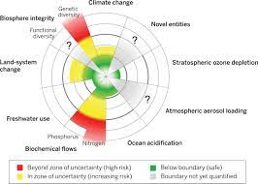

In total denial of climate science, Bill Gates says we need to use more fertilisers.
Justus von Liebig was the father of organic chemistry, the first scientist to explain the role of nitrogen in plants. Leibig’s work on nitrogen for plants was appropriated by greed for commerce. A new industry was created for external inputs of nitrogen called “growth stimulants”. Outraged at the distortion of his scientific findings in 1861, he wrote a book The Search for Agricultural Recycling.
Leibig’s book was the voice of a true scientist, protecting his truth from the distortions of a pseudo science being created by commercial interests. As he writes, “I thought it would be enough to just announce and spread the truth as is customary in science. I finally came to understand that this wasn’t right, and the altars of lies must be destroyed if we wish to give truth a fair chance.”
The truth that Leibig was defending was that the soil is living, and its life depends on recycling, or what Sir Albert Howard called “The Law of Return” in the Agricultural Testament nearly half a century later. The lie he wanted to destroy was what he called the “chemical hocus pocus”, that you can keep extracting nutrients from the soil, giving nothing back and still have “high yields”.
Gates is continuing the “chemical hocus pocus” when he says:
“To grow crops, you want tons of nitrogen-way more than you would ever find in a natural setting. Adding nitrogen is how you get corn to grow 19 feet tall and produce enormous quantities of seed” (pg.123)
Nitrogen fertilisers deplete soil nitrogen because they destroy the soil organisms that produce nitrogen.
Earthworm castings, which can amount to 4 to 34 tons per acre per year, contain five times more nitrogen than soil (Navdanya, Principles of Organic Farming, 2006, pg 99, cited in Soil not Oil, Women Unlimited, 2008, pg 114)
A 20 year study in Doon Valley shows how Soil Nitrogen has increased up to 100% in organic farms, and has declined by up to 22% in farms fertilised by urea/synthetic nitrogen fertiliser .
(Vandana Shiva, Biodiversity, Agroecology and Regenerative Organic Agriculture, Westville publishers ,2018, pg 172)
Selling more fertilisers is good for the profits of the chemical industry, but it is not good for the soil or the climate.
We don’t need lab made foods for proteins. Our dals provide protein to us while they also fix nitrogen for the soil.
(Navdanya, Pulse of Life)
Pulses fix nitrogen non-violently in the soil, instead of increasing dependence on synthetic fertilisers produced violently by heating fossil fuels to 550 degrees centigrade. Chick-pea can fix up to 140 kg nitrogen per hectare and pigeon-pea can fix up to 200 kg nitrogen per hectare non-violently.
Indigenous people in Mexico have evolved a Maize variety that fixes nitrogen.
https://e360.yale.edu/features/indigenous-maize-who-owns-the-rights-to-mexicos-wonder-plant
In total denial of indigenous knowledge of nitrogen fixing by plants to provide nitrogen ignoring the knowledge of the ecology of soil, of soil organisms and soil as a living system produces nitrogen Gates is promoting nitrogen fertilisers and chemical intensive GMO soya as raw material for lab made fake food which is being labelled as “plant based”.
The symbiosis and synergy between animals and plant is vital to the renewal of soil fertility. Animals eat the straw and grass, and give us organic fertiliser, which feeds the soil organisms that create the nourishment to feed the plants that feed us.
Cows are herbivores. Their diet is grass and straw. To digest fibre rich food, cows and other herbivores have 4 stomachs. Artificial Feed is violence to the cow. Cows fed with rendered meat of dead infected cows gave us the “Mad Cow Disease”
(Vandana Shiva, Mad Cow or Sacred Cow in Stolen Harvest, Indian Research Press)
Intensive grain feed is not adapted to the cows digestive system, that is why animals in factory farms and CAFOs (Concentrated Animal Farm Operations) stink and cause air and water pollution. Factory farms emit methane, a green house gas, because animals are kept in large concentrations and are fed intensive soya feed.
In denial of the biology of herbivores, the synergy between plants, animals, humans Bill Gates blames the cow, not factory farming, for climate change.
“Look inside a person’s stomach and you’ll find just one chamber where the food starts getting digested before making its way to the intestinal tract. But look inside a cow’s stomach and you’ll find four chambers……producing methane as a result (pg 117, How to avoid Climate disaster).
The methane emitted from cows fed naturally on pasture, or on grass and straw, is very small and is degraded by the methanthropic bacteria that feed on it – so they aren’t a problem for climate change. Methane stinks. Cows on our small farms and small dairies do not stink. They have a wonderful natural aroma. All ecological systems are based on plants and animals working in synergy. Regenerative organic systems based on the science of agroecology reverses the climate crisis.
There is a synergy between animals and soil and farming. Farmers provide food to animals and animals provide fertiliser to the soil, increasing fertility, and improving fertility.
Plus the correct animal husbandry systems increase soil organic matter, by drawing down CO2 from the atmosphere so that cows are a solution to reversing climate change.
On the other hand, the nitrous oxides, ammonia etc from chemical fertilizers, the CO2 from the loss of soil organic matter, the diesel from the huge tractors etc from industrial farming are a significant part – up to 50% of anthropogenic GHG emissions. Fake foods feed the climate crisis. Cows raised regeneratively reverse the climate crisis.
(Private communication, Andre Leu)
The industrial, corporate system that has given us Climate Change is being put on fast forward as a fake solution so corporations and billionaires can make more profits. The ecological, small scale, decentralized systems that are the solution are being criminalized on the basis of fake science and fake media.
The alternative to the factory farming of animals is not getting rid of animals. It is treating them with care, love and respect as indigenous cultures do. Cruelty to animals is built into the industrial food system. The violence to animals in factory farming is driven by profits and greed. We can end animal cruelty by putting an end to factory farming, and putting an end to the subsidies that promote factory farming, destroying small farms.
Allowing profits and greed to promote fake food, displace real food, drive farm animals and small sovereign farmers to extinction is violence against animals and the small producers who depend on them for livelihoods.
Designing extinction of our animals on small farms and small dairies through promotion of fake lab food is not an end to cruelty. Extinction by design is the highest cruelty.
Fake Food is a violation of food as a living system that connects us to the ecosystem and other beings. It indicates ignorance of the diversity of cultures that have used a diversity of plants and animals in their diets. Humans have had non-violent relations with animals over millennia. Our cows are sacred. We have ceremonies for them. We have reverence for them. We take care of them as part of our family.
The violent relationship is part of the industrial age of factory farming. Violence and non-violence are the true test of our relationship with our relatives in the plant and animal world.
The slippery slope to Fake Food begins with meat. But Fake milk is also being promoted. Recently, the first ‘animal-free’ ice cream was launched by the start-up ‘Perfect Day’, co-founded by Ryan Pandya and Perumal Gandhi. They introduced animal protein in microbes through genetic engineering and used them to produce proteins “that are identical to those of a cow”. As Pandya states, their synthetic product has the “heart and soul of being plant based, but is an animal protein.”
Source: https://fortune.com/2019/07/11/first-animal-free-ice-cream-perfect-day-dairy-alternative

Gates is even promoting fake breast milk as a solution to Climate Change!
Despite the known hazards caused by breast milk substitutes and notwithstanding regulations, the race for developing substitutes for breast milk has intensified.
Bill Gates’ climate change investment firm, Breakthrough Energy Ventures, has invested $3.5 million into “Biomilq” which is targeting infant nutrition by attempting to reproduce mother’s breast milk in a laboratory as a solution to climate change! No surprise of course that there is a patent pending for Biomilq.
Rushing to find substitutes for natural ecological processes and then patenting them has been the trend for making profits from life and its living processes in recent decades.
https://navdanyainternational.org/publications/gates-to-a-global-empire/
https://www.cnbc.com/2020/06/16/biomilq-raises-3point5-million-from-bill-gates-investment-firm.html

Fake food raises multiple ethical and ontological, ecological and economic questions. Is synthetic milk made in labs “breast milk? Is cow protein produced using microbes in a lab a “plant product”? Is getting rid of cows and other animals and pushing them to extinction protecting the animals? Is it violence or non-violence?
The slippery slope of Fake Food which today promotes meat and dairy without the living animals as sentient beings and our relatives in the earth family will tomorrow say we don’t need plants. All food can be synthesised and genetically engineered in the lab. The Monsanto’s and Gates are already talking of farming without farmers, and farm free food. And Big Tech is already talking about 99% people being useless in the future because AI and Robots will replace them. Denying diverse beings the right to life and treating species and people as disposable is the highest form of violence.
If we allow greed and violence to rule, we will have more destruction of biodiversity, more destruction of the climate, mare pandemics and more chronic diseases.
We can either choose a future that intensifies the violence of industrial food systems against farmers, against animals, against plants and against the planet by participating in the corporate vision of farming without farmers, without animals and without biodiversity. Or we can choose a non-violent future based on Earth Democracy: living non-violently with all beings, recognizing their right to live free of violence, recognising our duty to have respect and reverence for them and give them love and care. Instead of greed based food systems that have given us climate change and disease pandemics, we must protect and promote our small farm, small livestock economy as a solution to both the public health catastrophe and the climate emergency.
Our food sovereignty and economic sovereignty depends on real farmers growing real food for 1.36 billion Indians. For this we must create sovereign economic policies and independent science that protects the planet, the livelihoods of our small producers, and the right to healthy and real food of all people. We must resist the “hocus pocus” of fake food, fake science and fake economics.
https://www.navdanya.org/bija-refelections/2021/05/27/future-of-planetary-and-peoples-health/

