Up from the South: New Models and New Directions
University of Texas at Austin
November 2015
There are plenty of examples about the very pernicious relation between debt and democracy. Democracy, austerity and the whole discourse about the inevitability of some specific kind of recipes of economic policy are directly used to erode democracy, not because of inexorable technical situations, but because of some specific targets and geopolitical interests involved.
It is important to discuss, in a broader framework, what the structural conditions and the roots of this crisis are, as for the need for re-regulation and a New Financial Architecture as necessary conditions, however not sufficient, in order to build a new horizon for the globe and for the possibility of a humanistic and democratic exit. The technical conditions for achieving this goal exist nowadays, economists and other people could have other scientific evidence and theoretical frameworks that could give you very solid foundations for another path. There is no inevitability, the whole idea that there is no alternative is a lie. An ocean of impossibilities was created in Latin America and the South thirty years ago and there are efforts to create the same ocean of impossibilities out of guilt, anxiety and through kidnapping imagination.
This is a crisis of civilization. Beneath the surface of macro and financial indicators there is a political and geopolitical crisis that has been latent for decades by now. Since the sixties there is a very important reduction in terms of the rhythm of growth because of political decisions that surrender to the conditions imposed by a new type of power, a new structure of power and a dynamic of power that is an excrescency of monopolistic financial capitals but not related to production and not even related to monopolistic productive capital; devoted specifically to speculation.
Graph 1. Stock Exchange index and real estate prices at a global level

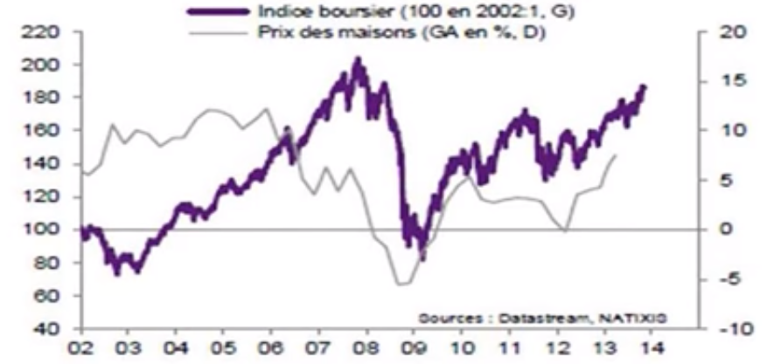
Graph 1 is very significant to understand, not only the limits of the solutions that they imposed upon the world, but also the tremendous possibilities in political and technical terms to build up alternatives. “They” stands for a very tiny minority and their interests that are time after time working against the interest seven billion human beings. This is why we need to build up alternatives with very sound theoretical foundations. This is not a financial crisis that has been worsening, this is the financial expression of much deeper situations. We are in the middle of a structural crisis of overproduction.
The previous similar situation for the system was one hundred years ago and it led to two World Wars which exemplifies the magnitude of the dangers we have to face today. It is necessary to build up a global alliance of all decent people in order to prevent a horizon of war, destabilization and chaos.
What is going on, and it is very difficult to admit, is that modern crises are not scarcity crises like economic textbooks used to say, those are archaic type of crises. Nowadays, Capitalism is prisoner of its own success, the productive rush of capitalism has created a flood of cheap merchandise that do not support the pretensions of high profit rates, which creates this absurd, contradictory and paradoxical situation of overproduction, not referring to overproduction from the point of view of satisfying the species needs but from the point of view of the interest of capital.
Part of the solution to this overproduction structural crisis, that was symptomatic at the end of the sixties, became precisely the main feature of the current situation: globalization and financiarization. We are living today the crisis caused by the remedies to the structural crisis of capitalism. Basically what we have here is hard to believe, to use an example: 8 months ago the patent of 3-D printers expired and very few people even knew there existed 3-D printers because patents where imposed to preclude the possibility of the diffusion of this new technology, also on this realm we find plenty of examples of programmed obsolescence in order to saturate markets and artificially create new market with niches for more profitability against the interest of mankind and bringing a new hyperbolic situation of waste capitalism and with a tremendous impact on the horizon of sustainability.
In this sense, capital has to create new traps in order to provoke artificial monopolies that have a pervasive effect over the whole industrial organization in terms of the productive of the productive capital and also has a tremendous demand over the performance of finances which is precisely one of the main new irreversible developments that have created a new kind of capitalism in the last few decades.

Graph 2. Overproduction since the 60’s: A prolongued Kondratieff B Phase. Percent utilization of industrial capacity

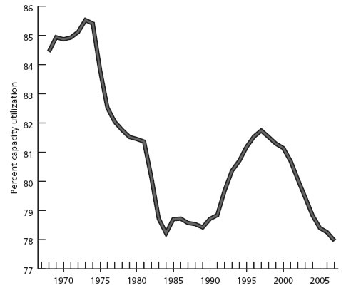
Source: Economic Report of the President, 2008, Table B-54 – Capacity utilization rates, 1959-2007
In all developed economies you generally have an idle installed capacity of 30 to 40 percent. But that is out of a 100 percent that has been already eroded because of the reduced structural incentives toward productive investment.
For the first time in history there is a much more important effort to prevent the deployment of the current scientific and technical revolution than to commercially apply it precisely because it is counterproductive in terms of this crisis of overproduction. De-localization and de-linking of investment has created a de-linking of the relationship between finance and capital that has been the key of the success of capitalism since the Middle Ages and the Renaissance in northern Europe. There is a relative overproduction that reappears as a problem of monopolistic competition and that is key to understand what is going on, this is a key feature that goes beyond the traditional concerns about macroeconomics and financial issues.
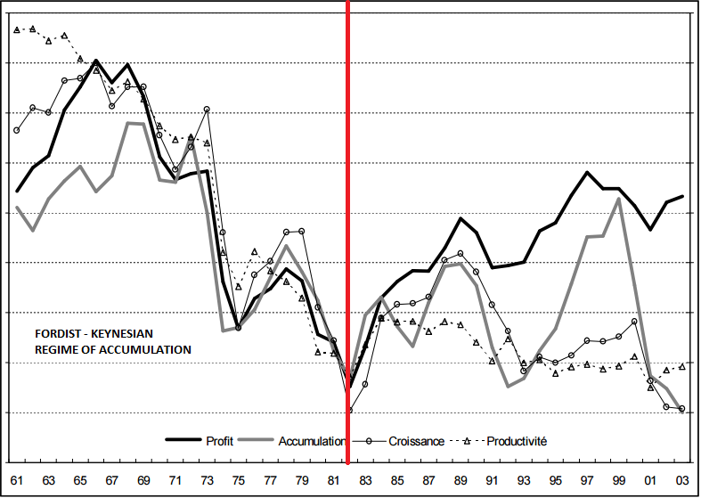
Graph 3. The curves of the global economy 1961-2003
Weighted averages according to the GDP for the <G6> (United States, Germany, France, United Kingdom and Italy)
Source: OECD, Perspectives économiques, 2003

You can see in the leftmost half of Graph 3 the six most important industrialized countries from the sixties and the bold black line represents an approximation to the rate of profit showing the tendency that comes after the Second World War and the tremendous manufacturing capacity of the United States at the end of the war that was, at the beginning, open to possibilities because of decolonization processes, the social democratic pact in the reconstruction of Europe, the New Deal also in the United States, the old structural reforms that occupied Japan and Taiwan were subject to, the agrarian and administrative reforms in Southeast Asia all of which created new markets for all this new capacity and the transformation of such from military use to civil use had some realization.
Nevertheless, the problem that Steindl mentions as maturity and stagnation of oligopolic markets had created a profit squeeze accompanied by the pressure of the trade unions that resulted in a political impasse. During Reagan, Thatcher and their neoliberal policies, represented in the second half of Graph 3, along with a very slow transformation of the conditions in the center but with a very important relationship with the rest of the world, especially the transfer of value, the transfer of surplus value from the periphery.
Graph 4. Volcker’s record defending finance 1979
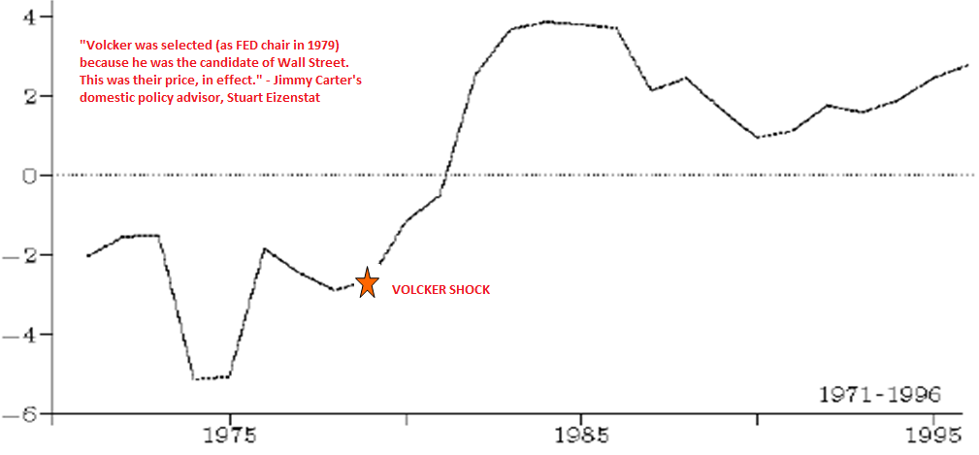
Source: Gerard Duminil and Dominique Levy
Graph 4 shows the Volcker coup d’état of 1979 through the increase of the interest rates that rendered plenty of loans acquired at 1-3 percent interest rate at that time but suddenly turned to a 22% rate which was totally unviable.
Regarding the debt trap, we can see the net transfer of resources as a result of the debt which was huge, but the triggering of all other mechanisms and macroeconomic manipulations that was part of the desperation of all countries trying to get some surplus in order to pay that debt, 150 countries fighting for a shrinking market with the effects in terms of trade, with a race to the bottom in terms of tributary standards, labor standards, environmental standards created a much larger transfer of resources that improved the situation of the rate of profit in the north.
This is very important because we are facing precisely a very similar episode, but the geopolitics today involve a neo colonization of the metropolis, no longer just the global south but also the whole submission of continental Europe to the interests of speculative capital.
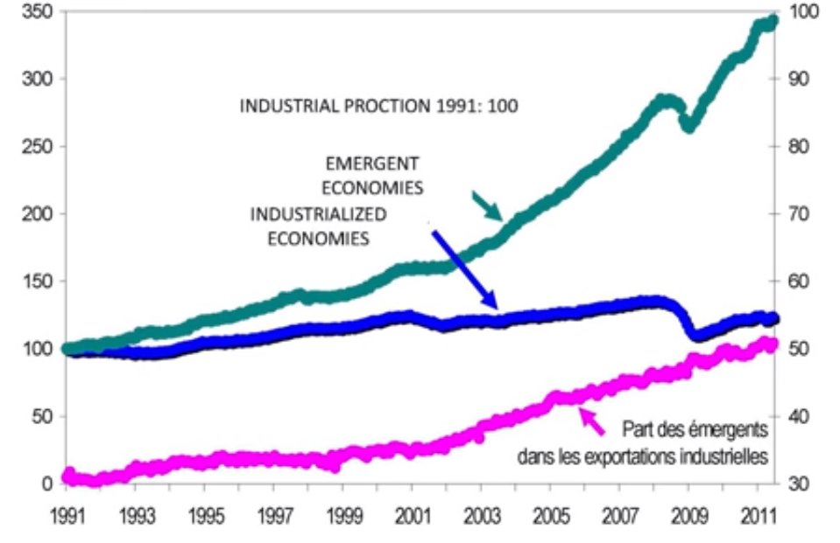
Graph. 5 Hegemony crisis and semi-periphery
The formation of semi-peripheries done through several processes, first the reconstruction of Europe after World War II followed by the Far East, then by the Tigers and the Dragons; processes that have exacerbated the overproduction crisis, which was concentrated, at the beginning, in the core of the system in the same geography of the United States. Now we find global imbalances and a hegemony crisis disguised as a commercial war and an exchange rate war. Part of this problem is that for the first time in geopolitical terms, the creation of these semi-peripheries is not under the military occupation of NATO, contrary to what happens with continental Europe, Japan, Taiwan and South Korea. Nowadays you find China, Russia, Brazil and South Africa that are not occupied by military bases of the United States, at least not directly and that has created a lot of tension that has been very evident in the last few years, especially after 2009 with a break up of “ChinAmerica” constituting the break of the explicit pact for some geopolitical arrangements on how to manage the global and financial imbalances created by the formation of this new semi-periphery.
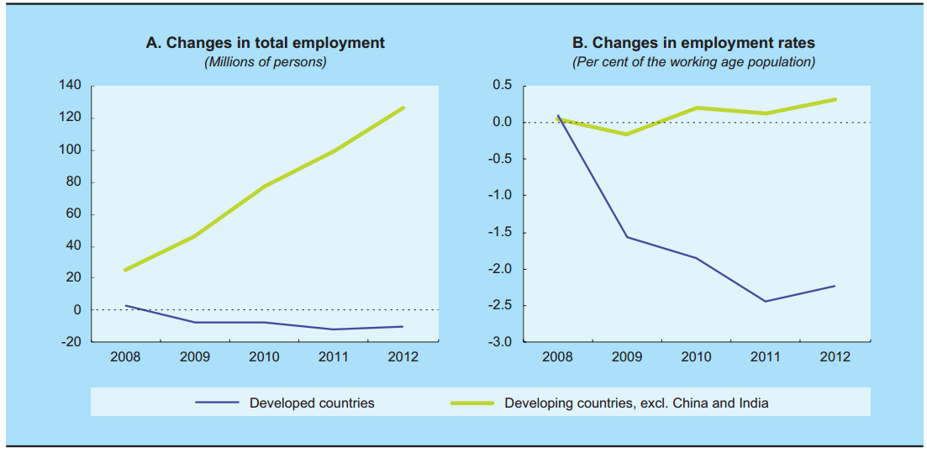
Graph 6. Changes in total employment rates in developed and developing countries, 2008 - 2012
Source: UNCTAD secretariat calculations, based on ILO, Key Indicators of the Labour Market (KILM) database; and UN-DESA, World Population Prospects: The 2012 Revision database.
That is not only a matter of figures and macroeconomic aggregates, there is a qualitative difference between the trend of labor productivity, represented in the dotted line in Graph 6, in the new semi-periphery, especially in the BRICS countries and the tendential decline of labor productivity in the core of the system. That is also related to the new nature of those powerful attractors in the global scene out of the center of the system expressed in the evolution of the system of multipliers of exports around all the commercial partners and imports the whole vigor of multipliers.
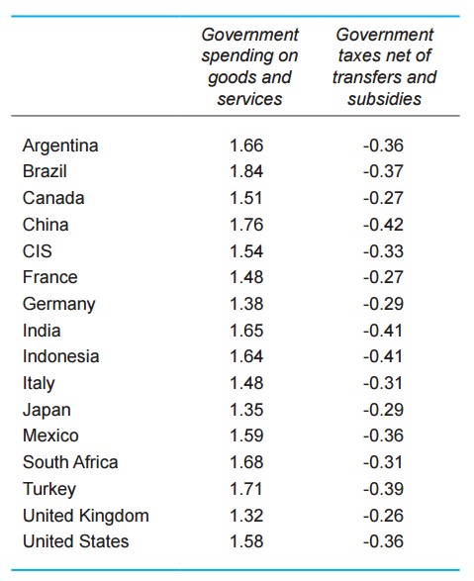
Table 1. Short Term Fiscal Multipliers
Source: UNCTAD secretariat estimates based on United Nations Policy Model
Table 1 shows the weakening of the Keynesian multipliers in the center, United States, Europe and Japan, basically due to outsourcing we are going to experiment the same type of weakening of the macroeconomic responses, China for example, because of the formal political decisions of the communist party to devote more interest in the improvement of the domestic market with all the part of services and tertiarization of the economy. These are very important elements to understand the tremendous macroeconomic asymmetry that we have now in terms of the capabilities to respond to the crisis.
The transfer of the industrial primacy of the old triad during the seventies was a geopolitical block of the triad to the new semi-periphery are worsening the structural problems of overproduction and the funny and tragic situation is that the recipe that the commanding elites are proposing is to asphyxiate markets. If you have a problem of overproduction the obvious course of action is to expand markets, but the austerity policies are only asphyxiating markets, are cutting wages, cutting budgets, reducing contracts, reducing the price of commodities from the south that render the type of revenue that could buy more exports from the north. This is not a zero-sum game but a shrinking-sum game that is going to exacerbate the conflicts.
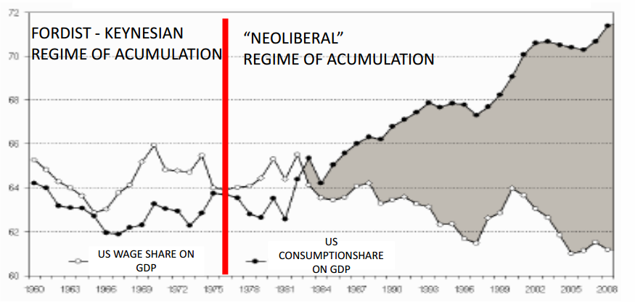
Graph 7. Debt-led consumption growth instead or Fordist commitment
Source: Husson, 2008
Furthermore, de-linking the consumption and income basis has created a structural trap in terms of indebtedness. Graph 7 shows the evolution of the United States where the black dotted line shows the evolution of consumption as a percentage of the GDP and in the grey dotted line you have the evolution of wages in the GDP and during the golden years of the so called Fordist regime of accumulation you have a coevolution between both, where more money resulted in more consumption. Nevertheless with the neoliberal policies you have a gap, a reduction in the path of wages and an increase in consumption. A gap that structurally must be filled with debt.
Neoliberal economists are used to say that it is necessary to live within your possibilities, but if one was to converge the evolution of consumption with the evolution of wages, the recession should have had started at the beginning of the eighties. This is not a flaw in the moral character of the people of Greece, Spain or the United States, this is a structural need of capitalism as it is. And the reduction in the share of wage income within the GDP is going to be worsening with the austerity policies and obviously the composition and the dynamics of debt are going to explode.
Despite agreeing with the analysis of Stephanie Kelton, Chief Economist of the U.S. Senate Budget Minority presented during the conference “Eurozone and the Americas” on November 2015 about the role of the public debt, the weight of the service of the debt in terms of distributional issues is tremendous because it links also to the tendency to the parasitic hypertrophic development of finance. Innovative finances are not only the irresponsible attitudes from a regulator of some regulators (that could be also part of the problem), are not only the casino spree of the population (that could be also part of the situation), but it is also another structural vector of the structural crisis of capitalism.
Graph 8. Rate of profit and Investment share on GDP
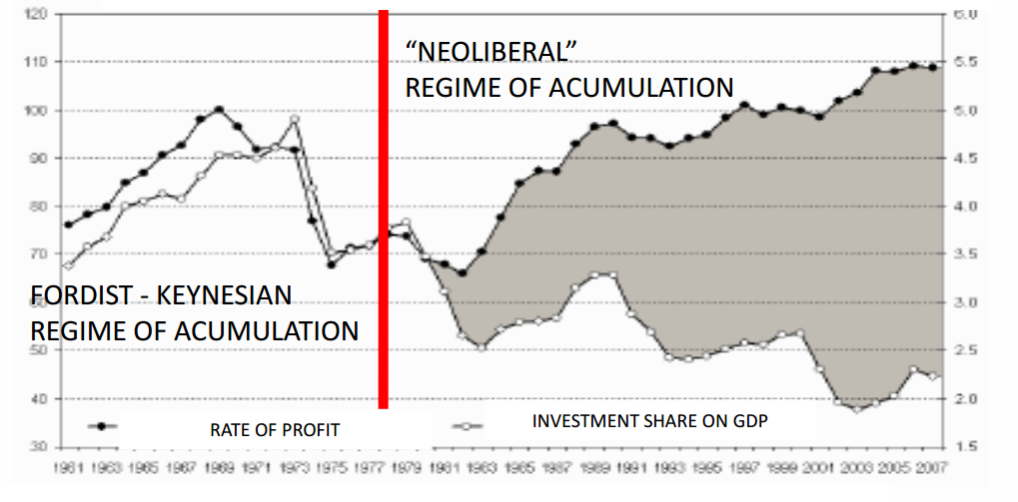
Source: Husson, 2008
It is shown in Graph 8, that during the Fordist – Keynesian regime of accumulation in the golden years of capitalism you have also a coevolution between income and investment for which the relationship between profits and productive investment where correlated, a situation on which the literature about the multiplier accelerated model is based on. However, with the neoliberal policies there is a cleavage.
The gap between the increase in profits and the reduction of productive investment opens the door for the hypertrophy of the financial sector. This situation is not present only in quantitative terms, the gap between both represents a qualitative problem.
The nature of the financial evolution has changed during the last few years as evidenced in the Graph 9 where represented in the black curve are the figures of the World Bank for the rate of growth of global GDP, commonly dubbed as the size of the “pie”, the real economy, which haves an increasing volatility and a constant reduction in the average level of growth. This contrasts with the orange line that shows the exponential rate of growth of derivatives during the last few years and renders a new phenomenon in the history of capitalism.

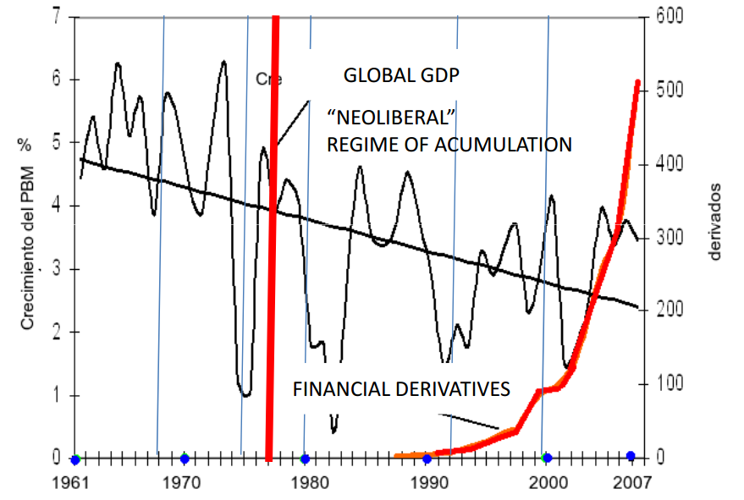
Graph 9. Global GDP Growth and Financial Derivatives
Source: World Bank and BIS, Retrieved from Beinstein, 2008
In financial terms, the only source of profit are the subjacent productive assets of all those financial investments are the real economies. The global real economy for 2010 was sixty three trillion dollars which is the approximate measure to the real size of the economy while the real debt, household debt, public debt, sums up two hundred and twelve trillion dollars resulting in a structural problem of insolvency and the current figures are even higher. This new feature on the functioning of the system is frightening where there exists these new type of debt called financial derivatives that do not resist even double party accounting. Derivatives are an erosion of the principle of private property. It were not the communists and not even the anarchists that managed to destroy the principle of private property, it was financial derivatives. They are bets with loaded dice on a casino of the global economy which can account according to some figures up to 1.5 quadrillion dollars even 2 quadrillion dollars, the figures of the Basel Bank of International Settlements is six hundred trillion dollars, the office of the Comptroller of the United States has another set of statistics accounting 648 trillion dollars and both are not compatible. It is not a coincidence that despite the huge importance and delicacy these types of financial weapons of mass destruction, as Warren Buffet labeled them, nobody has cared to have a disciplined and rigorous statistic of those kind of evolutions.
This can be compared to a musical chairs game. There are only six chairs and twenty one dancers, and on top of that, suddenly one hundred and fifty dancers come to the party. What will happen when the music stops? The central banks solution to this has been to keep the music playing, introducing a new dancer every five minutes. Those resources cannot be translated in terms of productive investment, productive credit or productive loans, precisely because there is a problem of overproduction. There is a problem of realization of those goods and services leading to all this money going to more speculation as it inflates the flaws in the financial market and therefore making it each time more detached from the needs of the real economy.
Graph 10. Price History: France, Castile, England and U.S. (1600 – Today)
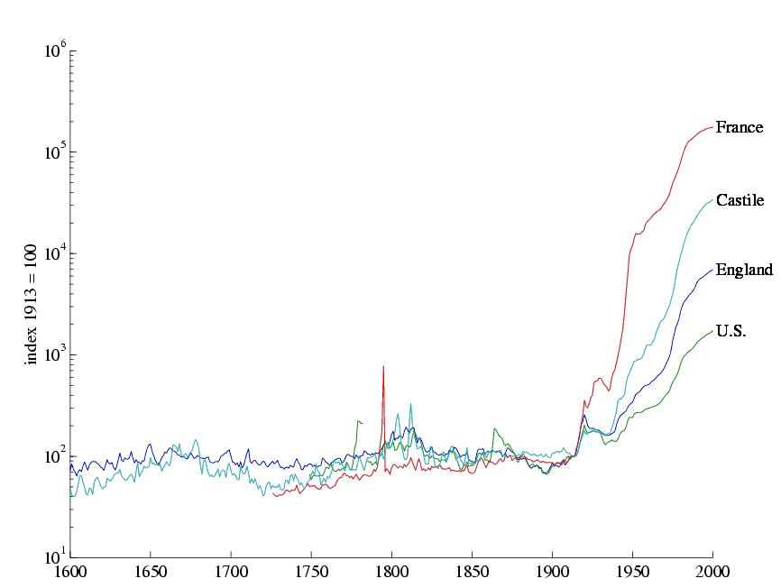
Source: Prof. Thomas Sargent webpage
Graph 10 shows the recurrence of these bubbles since the 1600. In terms of proportion there is no antecedent to the level of disproportionality and disconnection between the functioning of the stock market and the real economy. The results in terms of income distribution are significant.
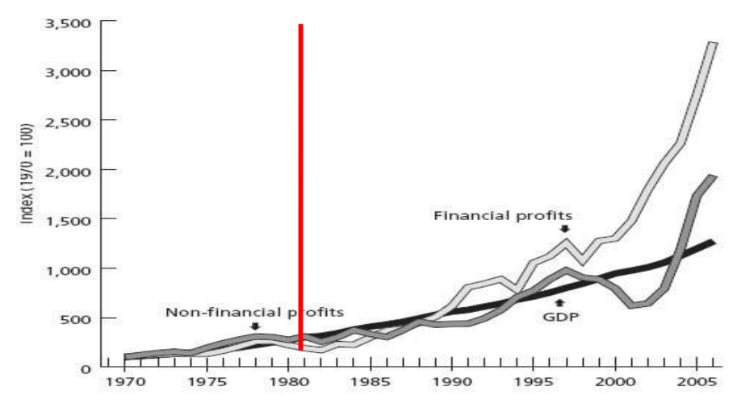
Graph 11. Growth of financial and non-financial profits relative to GDP (1970=100)
Source: Bellamy and Magdoff; Financial Explosion and Stagnation; Monthly Review; December, 2008
Graph 11 displays in the white line the evolution of financial profits in comparison to the evolution of the GDP contrasted with the evolution of the rest of the profits in the economy supporting this point.
Graph 12. World Corporations Concentration
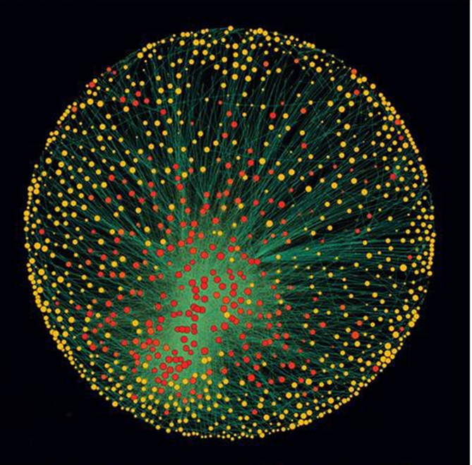
Source: New Scientist
The results in terms of wealth are tremendous, in Graph 12 there is a topological expression of the nodes and the ownership relationships among 37 million corporations from 2007, showing that only one hundred and forty seven of them control forty percent of the global GDP. This is not the one percent against the other ninety nine percent, this is the 0.00001 percent, and we are not taking into account tax havens, all the network of islands, mostly part of the British Commonwealth that are a monument for opacity.
Table 2. The top 50 of the 147 superconnected companies
1. Barclays plc
2. Capital Group Companies Inc
3. FMR Corporation
4. AXA
5. State Street Corporation
6. JP Morgan Chase & Co
7. Legal & General Group plc
8. Vanguard Group Inc
9. UBS AG
10. Merrill Lynch & Co Inc
11. Wellington Management Co LLP
12. Deutsche Bank AG
13. Franklin Resources Inc
14. Credit Suisse Group
15. Walton Enterprises LLC
16. Bank of New York Mellon Corp
17. Natixis
18. Goldman Sachs Group Inc
19. T Rowe Price Group Inc
20. Legg Mason Inc
21. Morgan Stanley
22. Mitsubishi UFJ Financial Group Inc
23. Northern Trust Corporation
24. Société Générale
25. Bank of America Corporation
26. Lloyds TSB Group plc
27. Invesco plc
28. Allianz SE 29. TIAA
30. Old Mutual Public Limited Company
31. Aviva plc
32. Schroders plc
33. Dodge & Cox
34. Lehman Brothers Holdings Inc*
35. Sun Life Financial Inc
36. Standard Life plc
37. CNCE
38. Nomura Holdings Inc
39. The Depository Trust Company
40. Massachusetts Mutual Life Insurance
41. ING Groep NV
42. Brandes Investment Partners LP
43. Unicredito Italiano SPA
44. Deposit Insurance Corporation of Japan
45. Vereniging Aegon
46. BNP Paribas
47. Affiliated Managers Group Inc
48. Resona Holdings Inc
49. Capital Group International Inc
50. China Petrochemical Group Company
* Lehman still existed in the 2007 dataset used
Source: New Scientist
Within the list of these companies it is possible to observe that mostly the banks are the main actors in the map of structural power in the world, precisely the same banks that out of corruption and incompetence have created the crisis and the financial implosion and the same banks that now are receiving charity from the Central Banks of the United States, Europe, Switzerland, England and Japan.
Is this going somewhere? After all the trillions of dollars that have been poured into the financial system, it is not healthier than it was 10 years ago and the key to this situation is the shadow banking. Shadow banking is the new relationship, the new type of liquidity neglected by the academia based upon the circulation and manipulation of derivatives which has displaced the axis of functioning of the financial system at the global level. The balances of payments of each country are each time less related to real issues as for the traditional exchange rate issues or Lerner elasticities, etc. Each time larger proportions of the balance of payments of each country are related to the functioning of this shadow banking at the global level and an increasing number of functions of the Central Banks are dedicated to the lubrication of the functioning of the shadow banking. And all of this situation out of the control of regulators, legislative frameworks of each country and completely out of the radar of international multilateral representative institutions.
Graph 13. The Anatomy of Global Corporate Ownership
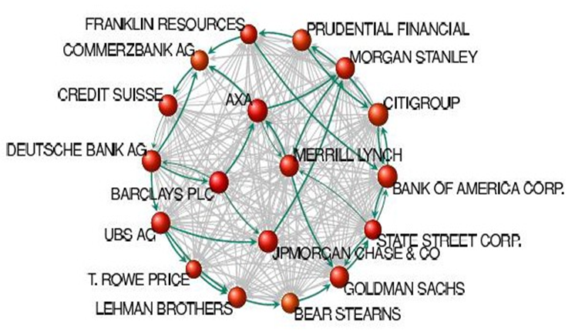
Source: Glattfelder, 2010
At the core of the map of the structure of ownership of big corporations, we can see the main actors again big banks being the protagonists of the current crisis and of the current “solutions” of the crisis related directly to a huge process of massive dispossession, income polarization and with one very clear outlet the industrial military complex.
Graph 14. Inflation Adjusted U.S. Military Spending (1962-2015)

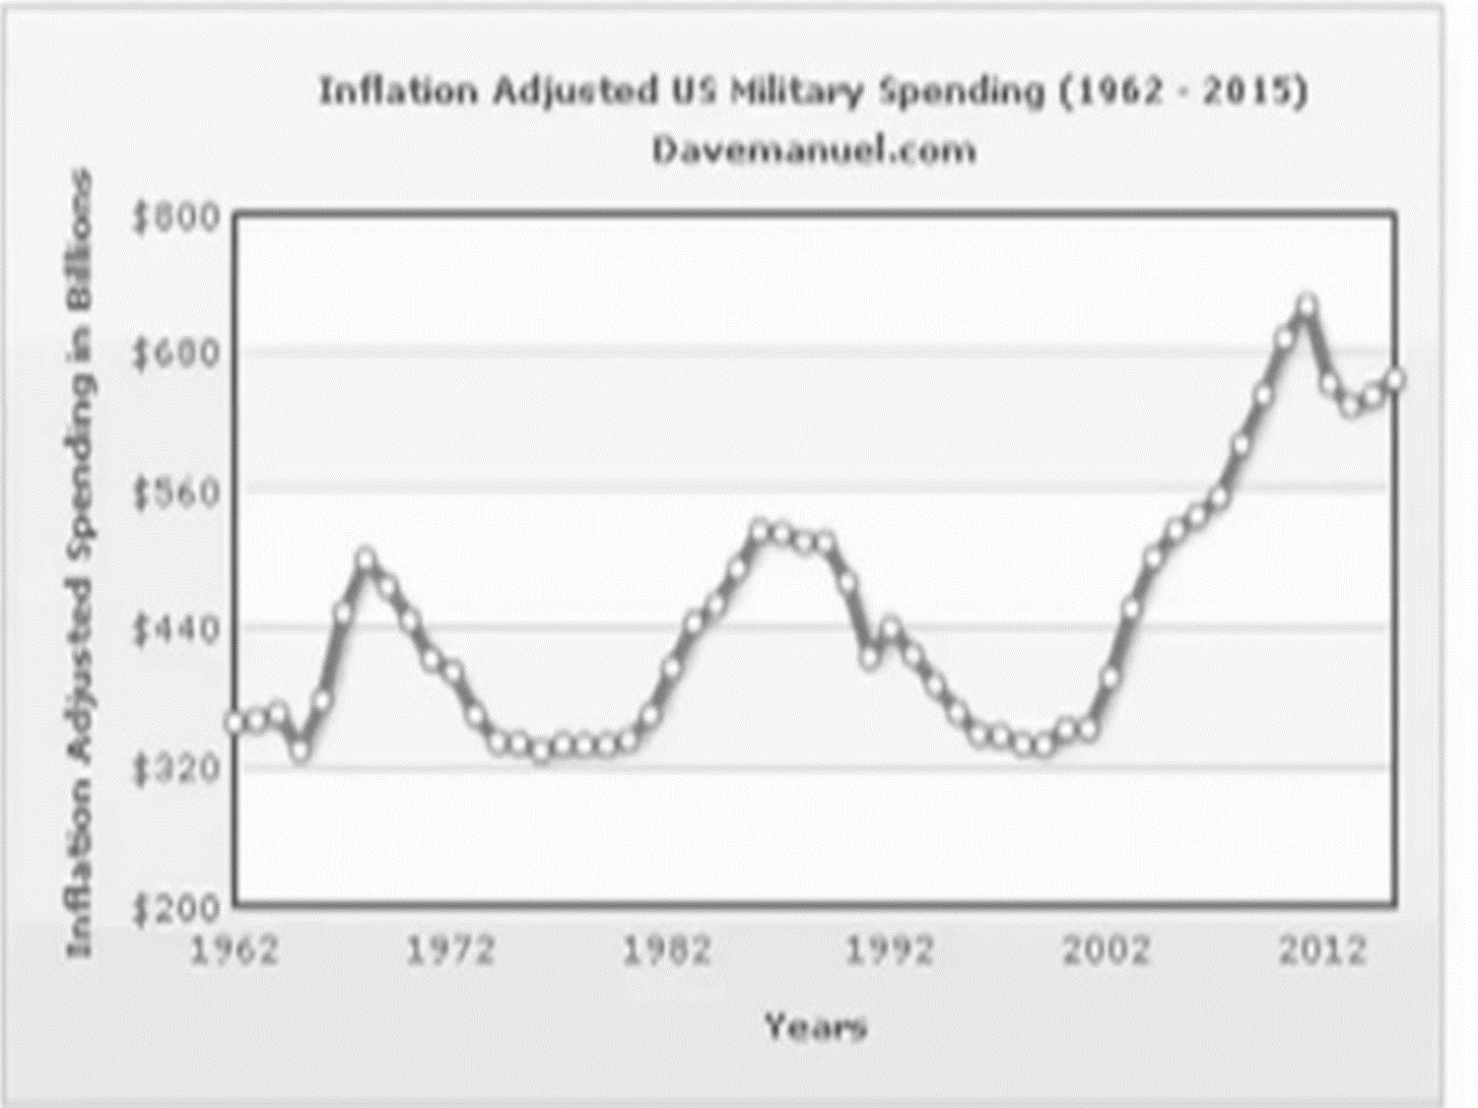
Source: www.davemanuel.com
In Graph 14 it is displayed on the graph what happens after Kennedy’s assassination, the Vietnam Peace, the fall of the Berlin Wall, the peace dividend, the Monica Lewinski “coup d’état”, the war against terrorism, and suddenly a reduction of the sales perceived as very dangerous for the rest of the world as we are talking about billions of dollars in business here.
Latin America fell victim of a genocide five centuries ago in the name of God and civilization, now the fashion is to bomb countries in the name of freedom and democracy. It is necessary to have an environment of respect for international law to work with stable societies and to build up the conditions for a green global New Deal. There are plenty of possibilities to accomplish this goal.
The old financial architecture is based upon a global and hierarchical system of debts that are going to keep on growing forever and that dictates the possibilities of production and consumption of 7 billion people, It is not about the morals of hard working people, it is about the impossibility to work that austerity politics and the public debt trap is creating everywhere; the domination of private monopolies of money-debt issuers, speculative finance, securitization and liquidity operations that have replaced democratic institutions all around the world; the transnationalization of finance and financiarization of transnationals has distorted the role of big productive enterprises, decades ago what was good for General Motors was good for America, but today what is good for Goldman Sachs is good for America? Is it good for the rest of the world? Non democratic corporations and institutions have much more power of decision than 7 billion human beings and as it happened one hundred years ago, the ghost of war is always profitable.
Graph 15. Contributions to Global Imbalances of Selected Groups of Countries 1970-2011

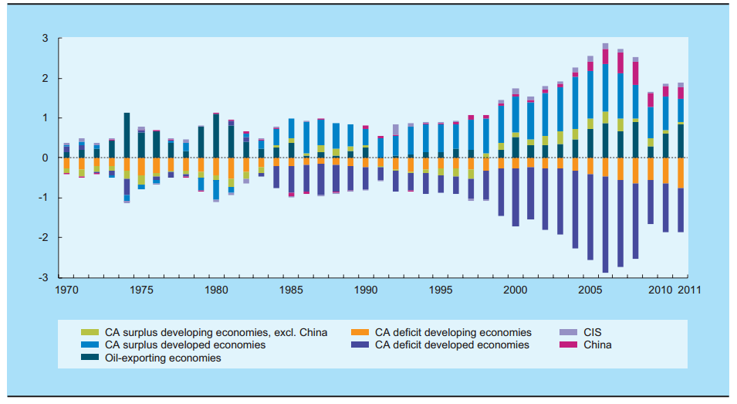
Source: UNCTAD secretariat calculations, based on UN-DESA, National Accounts Main Aggregates database; IMF, World Economics Outlook (WEO) Database.
In Graph 15 it is shown the type of solutions that macroeconomists used to be obsessed about: macroeconomic imbalances represented in the contributions of different countries to the external deficits. It was supposed that China, India and other countries from the South were going to finance the deficits from the North. The size of the lines and the arrows show the direction and the amount of resources mobilized in the effective financial system. There is no line that goes from China or India toward the United States or Europe which translates into a total de-linking of the real economy with respect to the functioning of the financial system even with the BRICS. It is necessary to recover a dynamic coherence between the development of finance and the needs of the productive system.
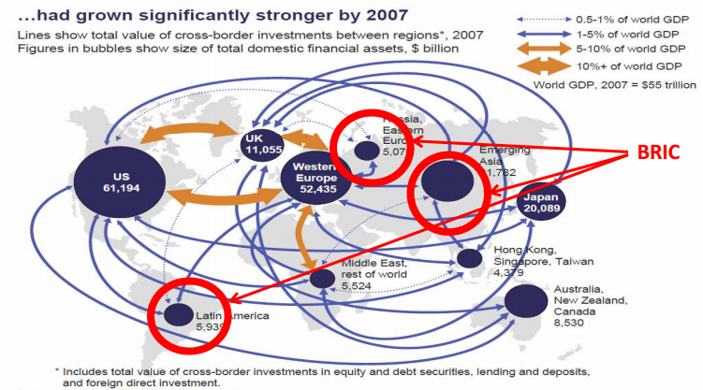
Graph 16. Financial Hegemony Politics
Source: McKinsey Global Institute Analysis
The financial hypertrophy leads to an agenda of destabilization because for the speculative financial capital it is not important to recover the loans, they are not interested in recovering the payment. The experience of Latin America, Southeast Asia and Africa shows that the business is in the perpetuation of debts. This parasitic and predatory logic must change in order to have a better situation.
The unsustainable balance sheet make represented in Graph 17 up has created such a distortion in the function of the economy that a need has arisen for redefining priorities for the North and the South from a political and democratic stand point. There is enough money for this corrections. According to the Bernie Sanders report, there are sixteen trillion dollars and then the University of Missouri corrected the figures to twenty trillion dollars. There are plenty of resources for education, science and infrastructure as civilized solutions to the crisis, nevertheless, no dollar have been spent on these fields in favor of funding banks and wars.
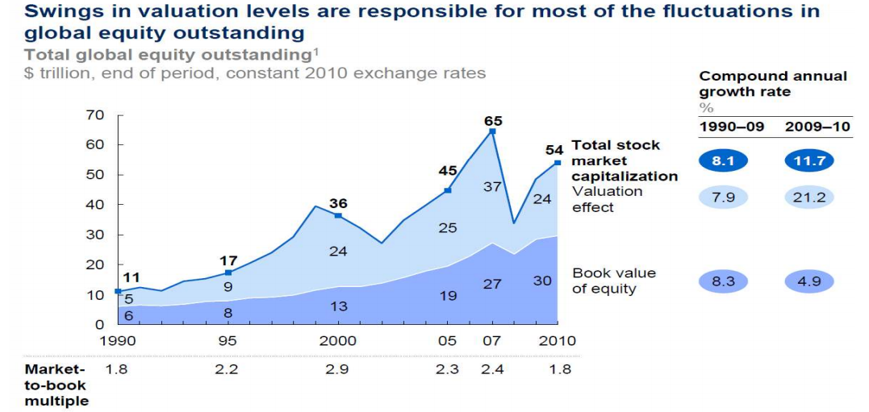
Graph 16
Source: Standard and Poor’s Datastream; Bloomberg; McKinsey Corporate Performance Analysis Tool (CPAT); McKinsey Global Institute Analysis
There is a need for a New Financial Architecture that can solve the structural distortions of financial markets and price formation at the international level comprising the complete manipulation of labor, interest rates, exchange rates, basic commodities prices, oil and energy prices, all of the long term decisions in terms of the sunk cost of fixed capital that are currently distorted. This New Financial Architecture should be structured around the Re-regulation of the financial markets and the re-orientation of finance in order to re-launch the economy, taking advantage of the new discoveries and innovations of the scientific and technical revolution.
There are a lot of resources even in Latin America. Paradoxically, Latin America is entering into a new phase of recession while the region has a large amount of resources and while it is a net lender to the rest of the world. It is in this sense that Ecuador has proposed a New Regional Financial Architecture with a new type of development bank, a new type of central banking and a new type of currency system based upon a system of compensation payments through a Clearance Union. This proposal is reflected in the Bank of the South, the Fund of the South and the new Regional system for compensation called the SUCRE, setting up the conditions for a new type of integration, including the possibility of block regional monetary and credit arrangements that could open the door toward a multipolar world that would make viable in the near future the possibility of relaunching the economy under the horizon of humanitarian and democratic values.

Graph 17. New Regional Financial Architecture Scheme
New type of Development Bank
Central Banking Network
Payment Compensation System
Bank of the South
Fund of the South
Regional Fiduciary Currency

